**Deploying Apache Project using Ansible via**

**Jenkins**

**Aim :** The project aims to Deploy Apache project on Node EC2’s using Ansible which will be triggered via Jenkins pipeline

**Git Hub repo to fork :**

[**https://github.com/akshu20791/apachewebsite**](https://github.com/akshu20791/apachewebsite)

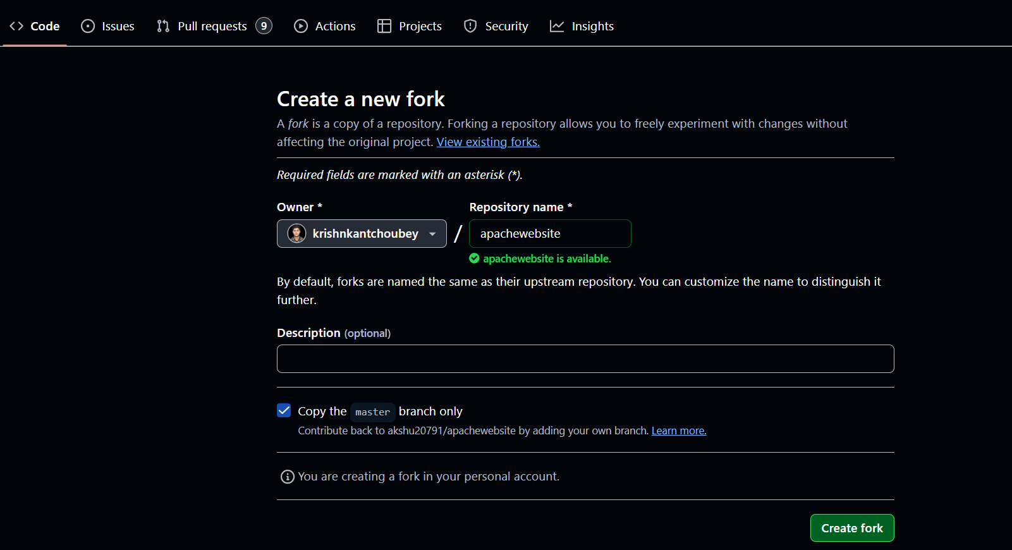

**Git Hub repo for reference :**

[**krishnkantchoubey/apachewebsite**](https://github.com/krishnkantchoubey/apachewebsite)

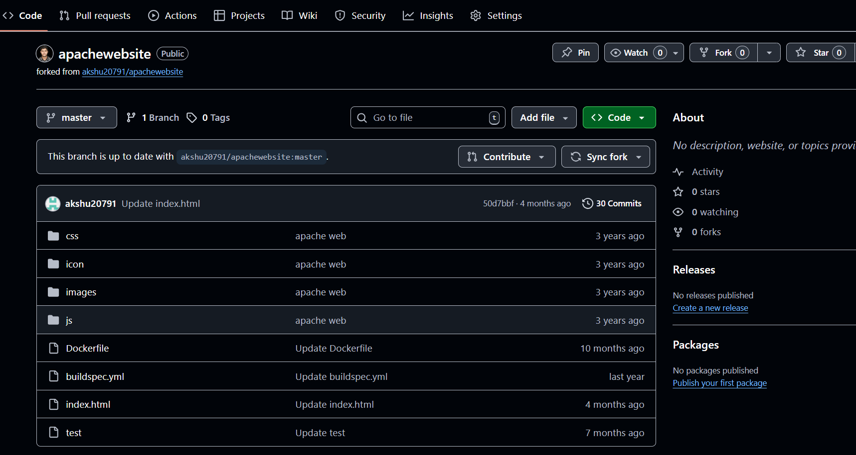

**Base plan :**

1.Create a Master EC2 with – Jenkins, Ansible, docker

installed

2. Create Cluster and nodes

3.Connect the Node to master

4.Make a Jenkins pipeline and deploy Apache project on all nodes by running Ansible playbook

**Steps to Follow:**

1. **Create a Master EC2 Instance**
2. **Create an IAM User**
3. **Install Required Packages and Tools**
4. **Create the EKS Cluster**
5. **Configure and Establish Jenkins**
6. **Install Necessary Plugins in Jenkins**
7. **Set Up Dynamic Inventory for Ansible**
8. **Connect Ansible Master with Nodes**
9. **Execute the Final Deployment Using Jenkins Pipeline**
10. **Verify and Confirm Successful Deployment**

**Step 1. Create a Master EC2**

a) Give name to EC2 and select AMI as Ubuntu 24.04LTS

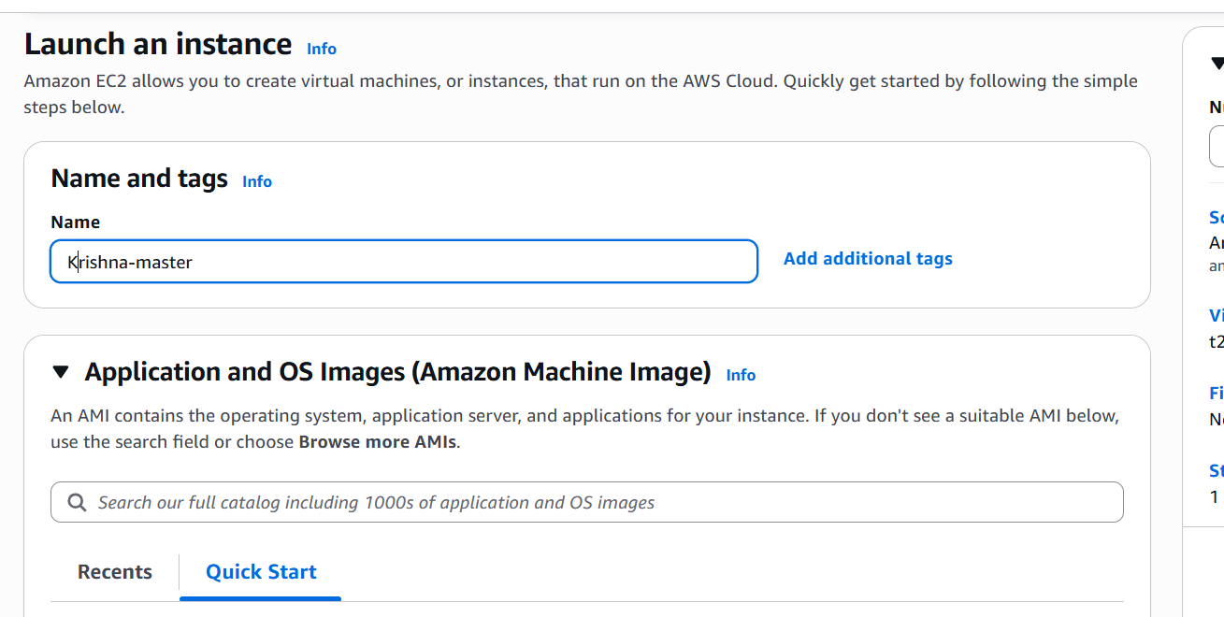

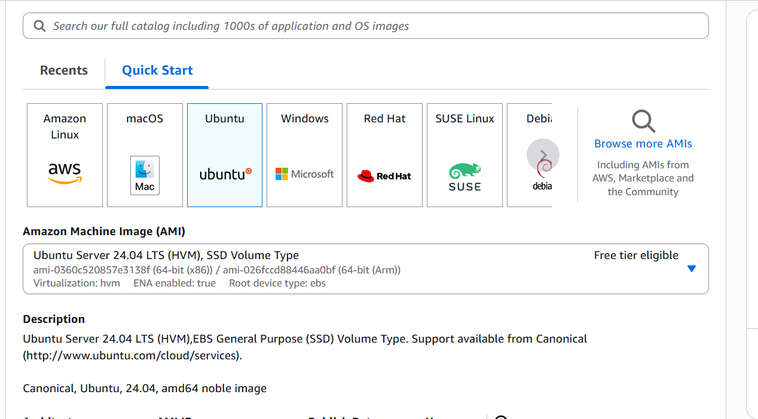

b) Select instance type as t2.large ( since this is master EC2 it will require large size )

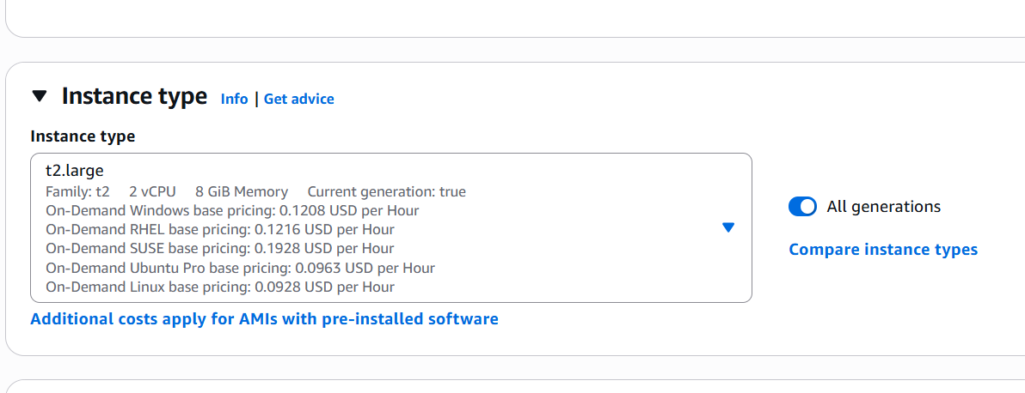

c) Create a Key pair ( Save it we will use this key pair throughout the project )

Give it name -> key pair type = RSA -> Key file format = .pem -> Create key pair

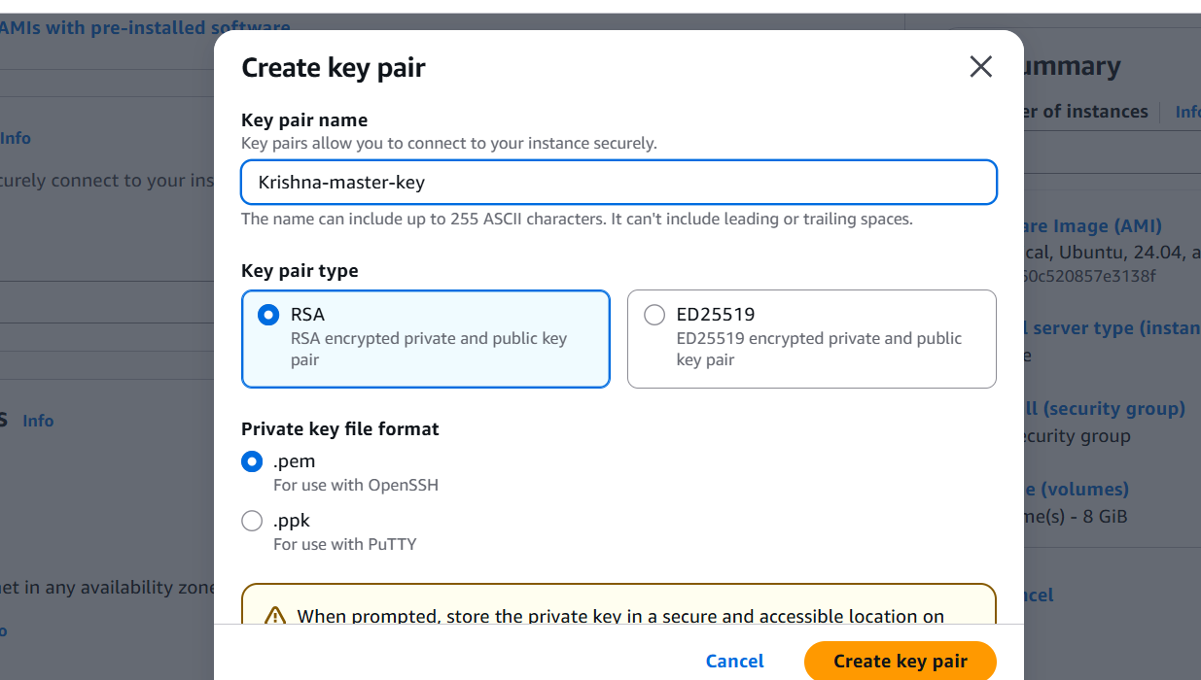

**d) Create Security Group**

1. Click on **Create Security Group**.
2. Enter the following details:  
   * **Name**: Provide a suitable name for the security group.
   * **Description**: Enter a brief description.
   * **VPC**: Select the **default VPC**.
3. Add the following **Inbound rules**:

| **Type** | **Protocol** | **Port Range** | **Source** | **Description** |
| --- | --- | --- | --- | --- |
| SSH | TCP | 22 | 0.0.0.0/0 | Allow SSH access |
| HTTP | TCP | 80 | 0.0.0.0/0 | Allow web traffic |
| HTTPS | TCP | 443 | 0.0.0.0/0 | Allow secure web traffic |
| Custom TCP Rule | TCP | 6443 | 0.0.0.0/0 | For Kubernetes API access |
| Custom TCP Rule | TCP | 8080 | 0.0.0.0/0 | For Jenkins access |

4.Click **Create Security Group** to finalize

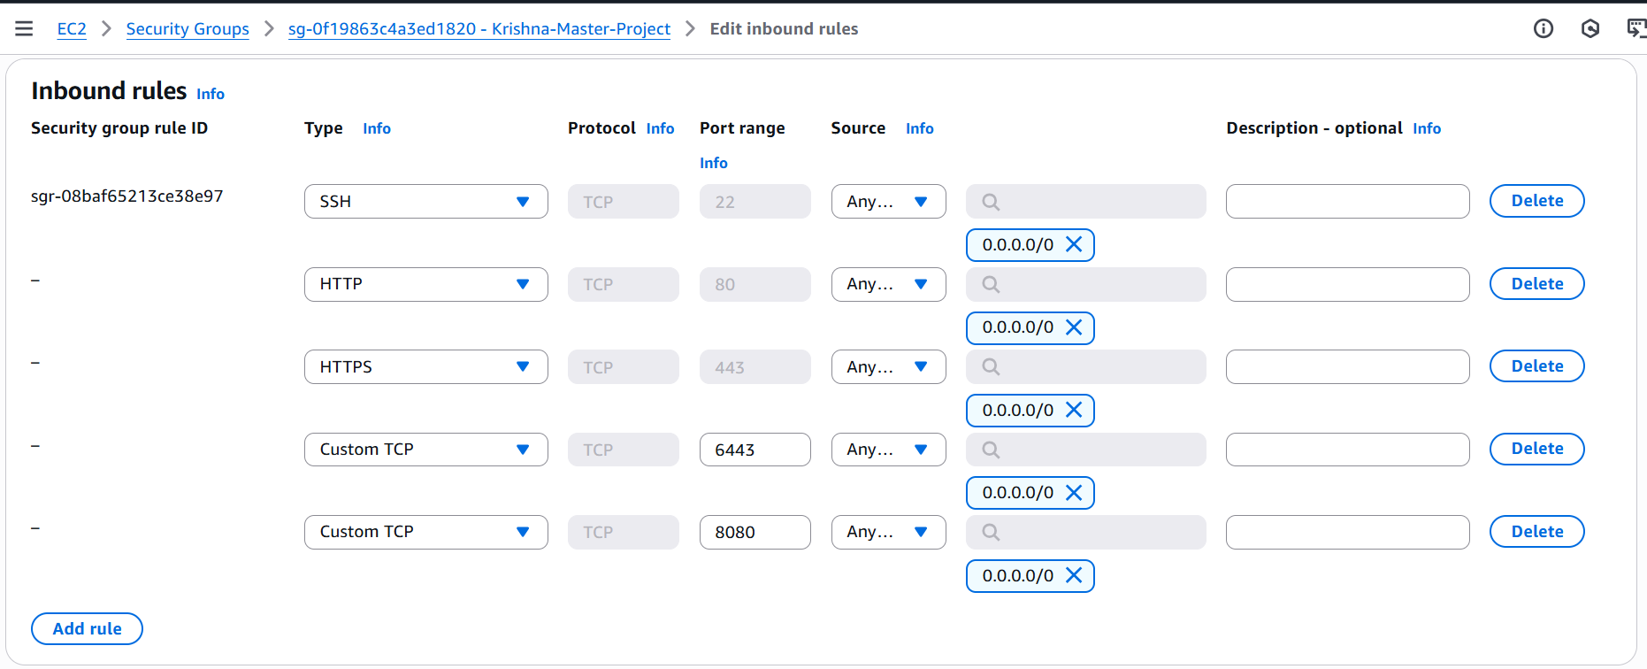

e) Configure Storage as 1x30 GiB gp3 then click on Launch Instance

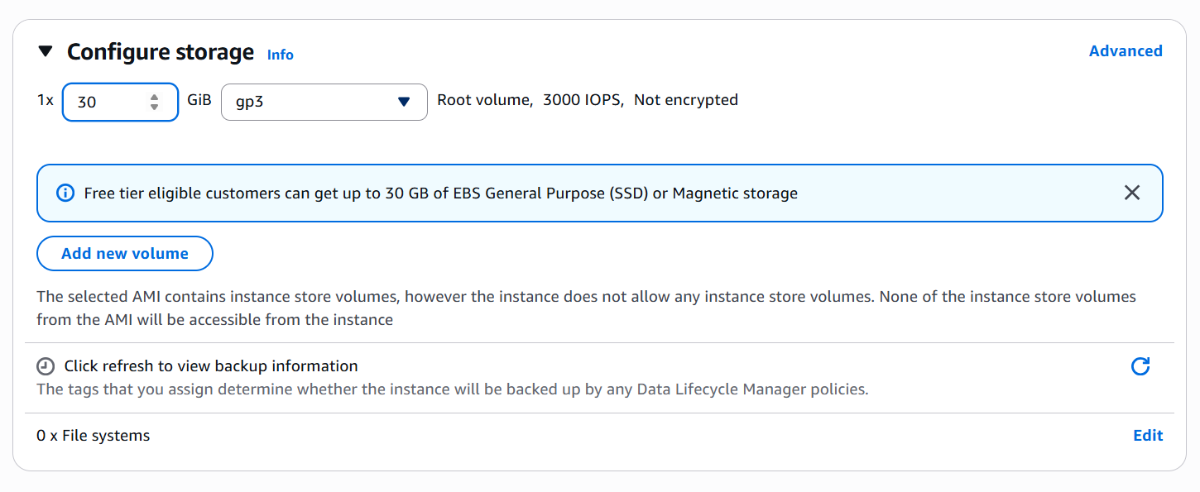

**Step 2 . Create IAM User**

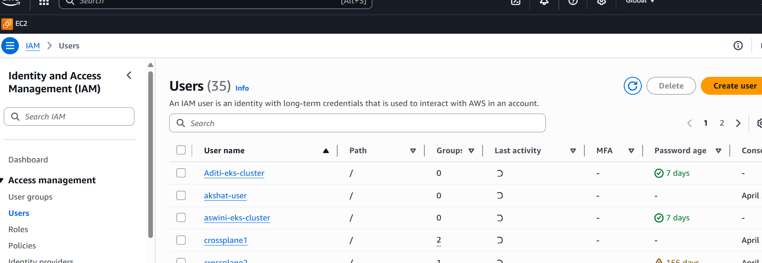

**b) Create IAM User**

1. Enter the **Name** for the IAM user.
2. Check **Provide user access**.
3. Select **I want to create an IAM user**.
4. Click **Custom password** and enter the desired password.
5. Uncheck **User must create a new password at next sign-in**.
6. Click **Next**.
7. Skip all additional settings and click **Next** again.
8. Click **Create user** to complete the process.

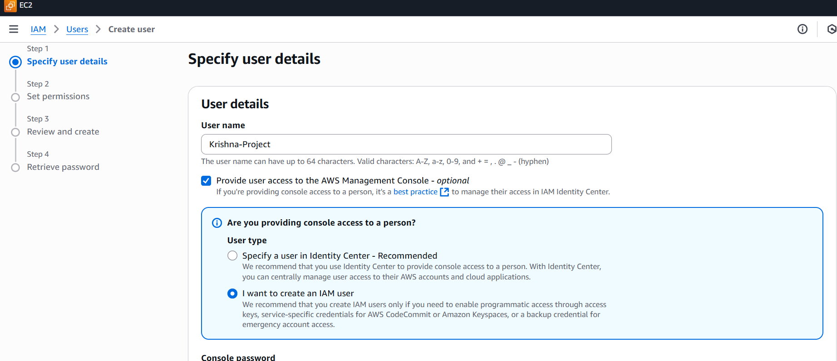

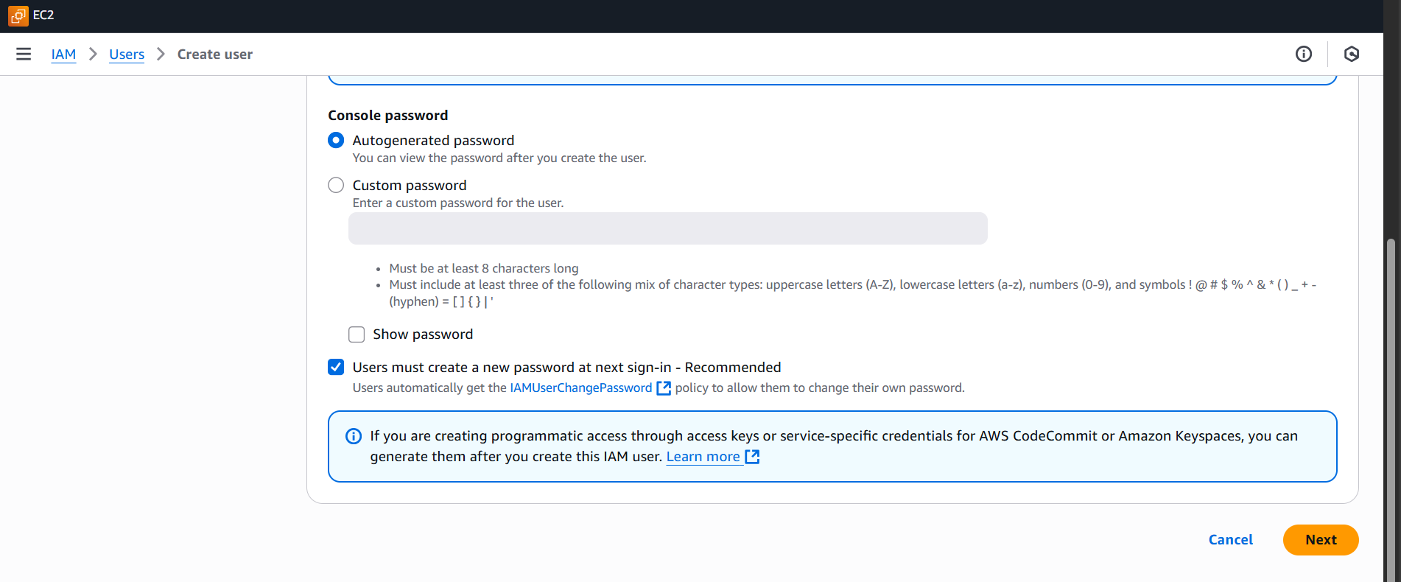

c) Move back to user list and select your user -> click Add Permissions -> Click on Attach Policies Directly

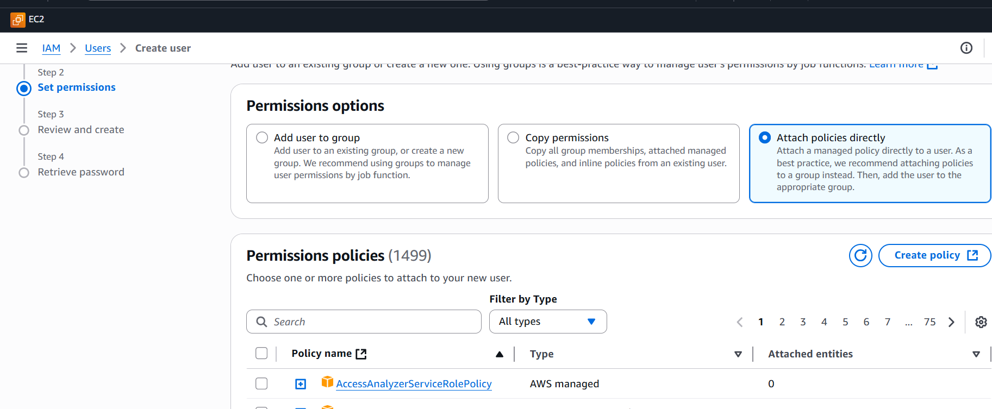

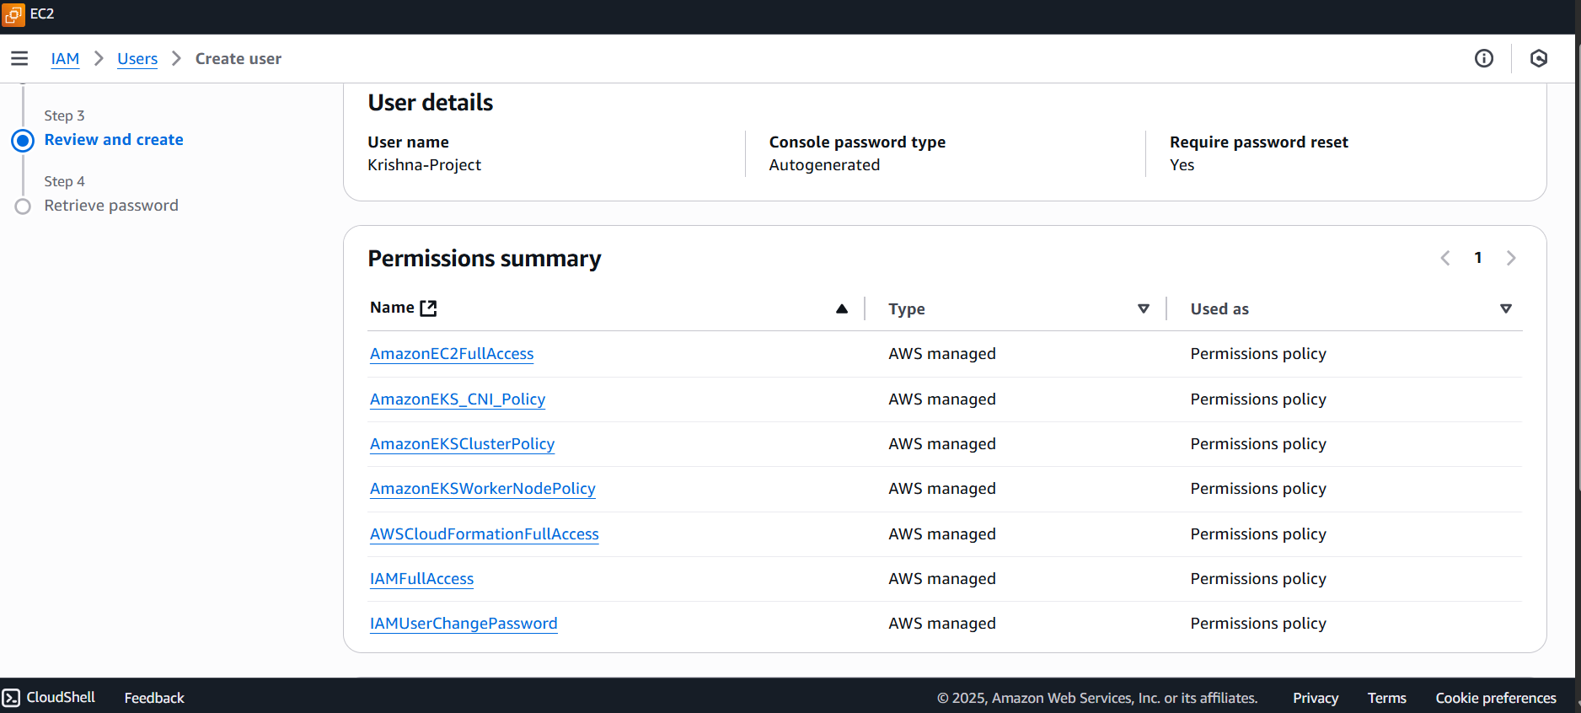

Click on Add Permission -> Create inline policy

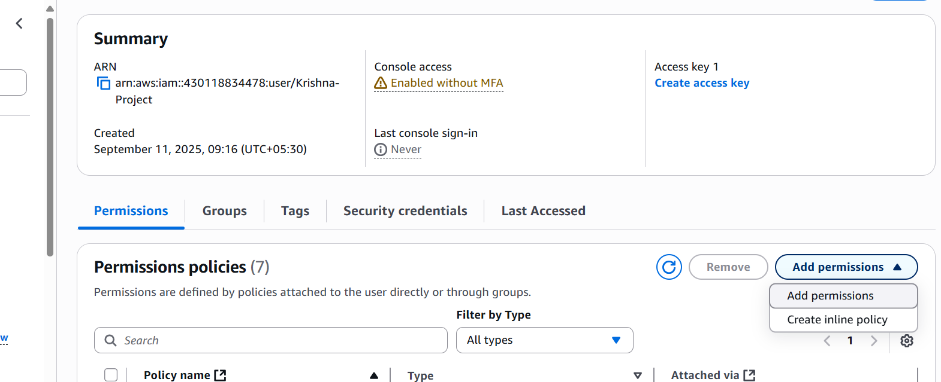

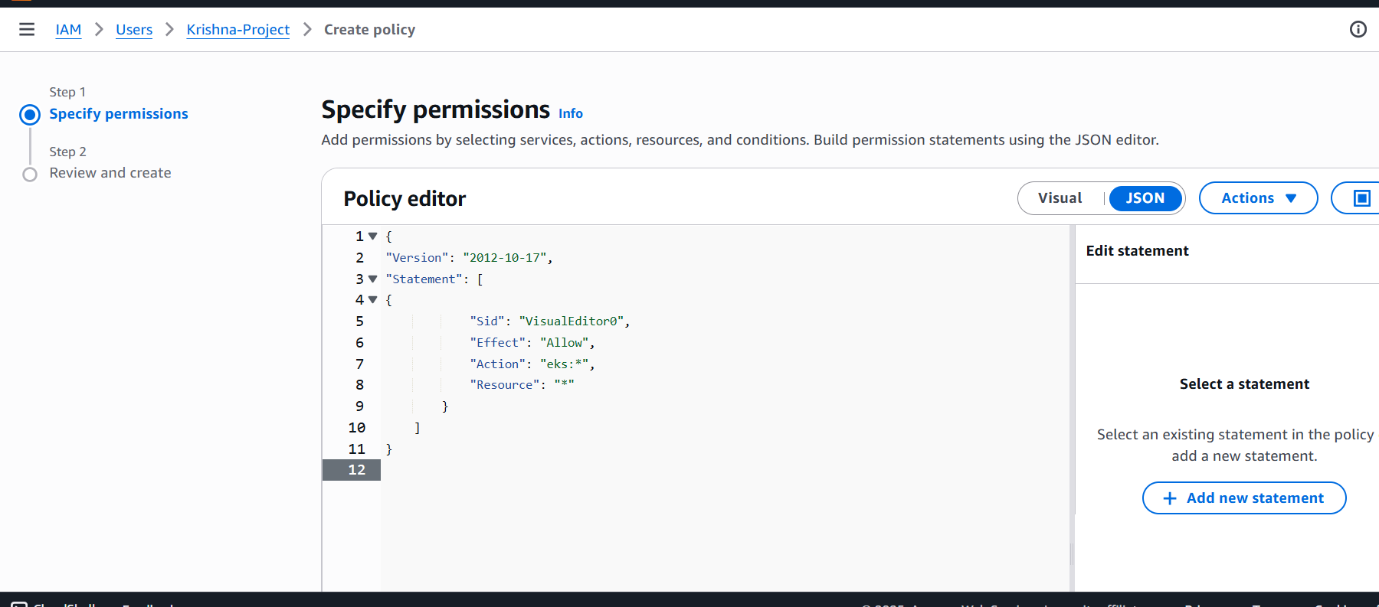

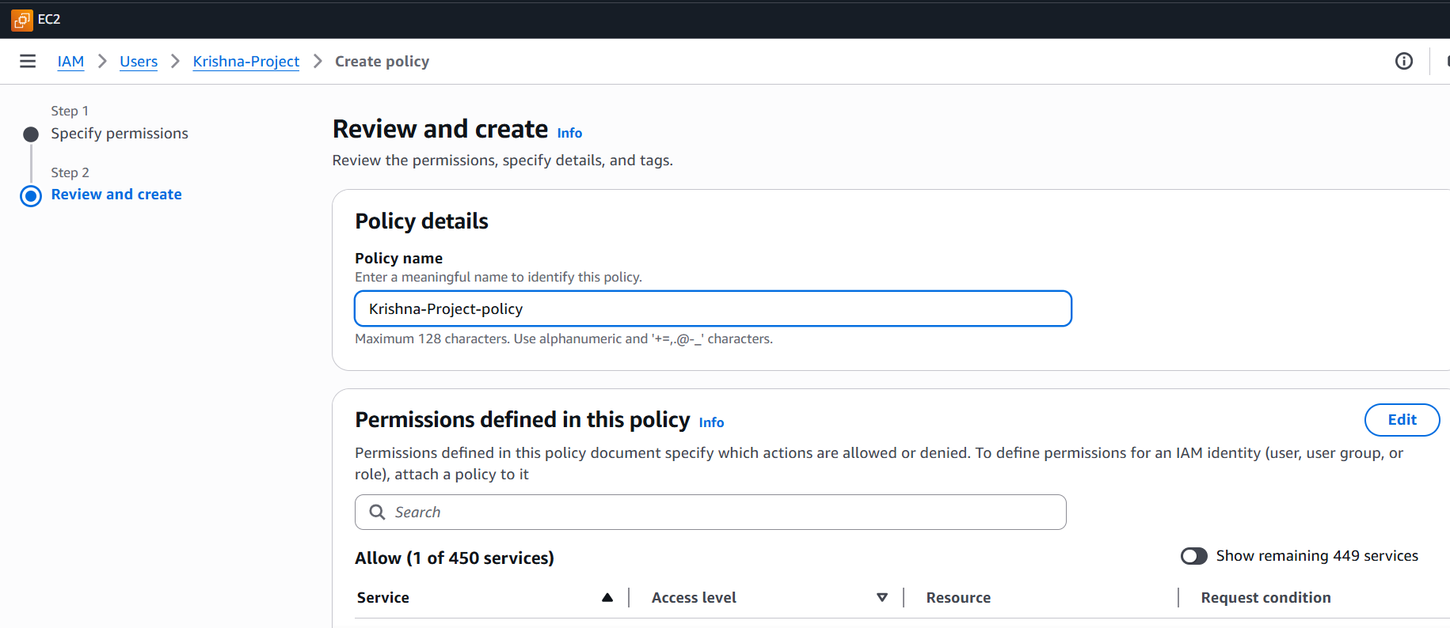

Now you will have 8 policies attached to user

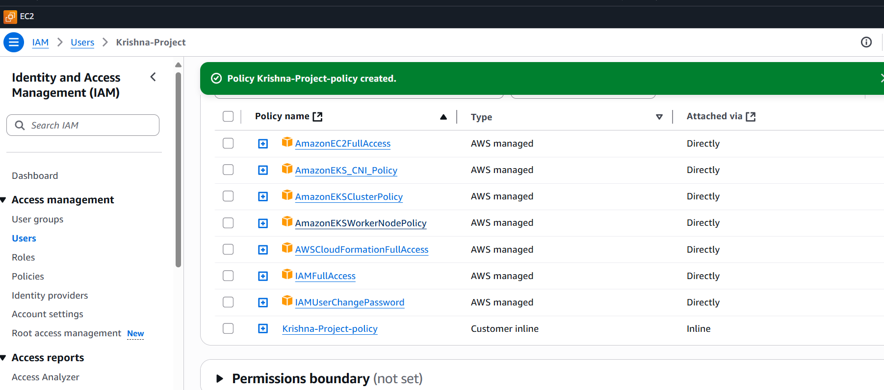

**Step 3. Installations**

**a) Connect EC2 to ssh**

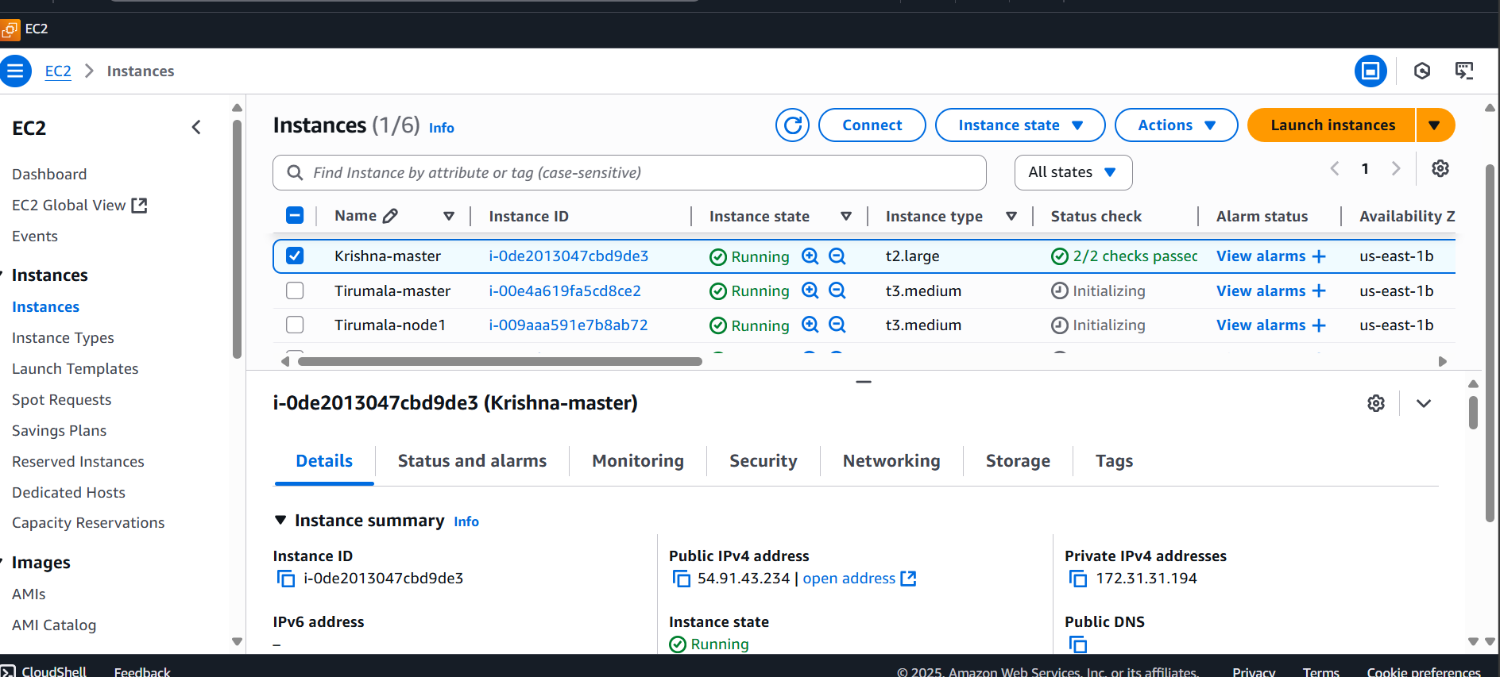

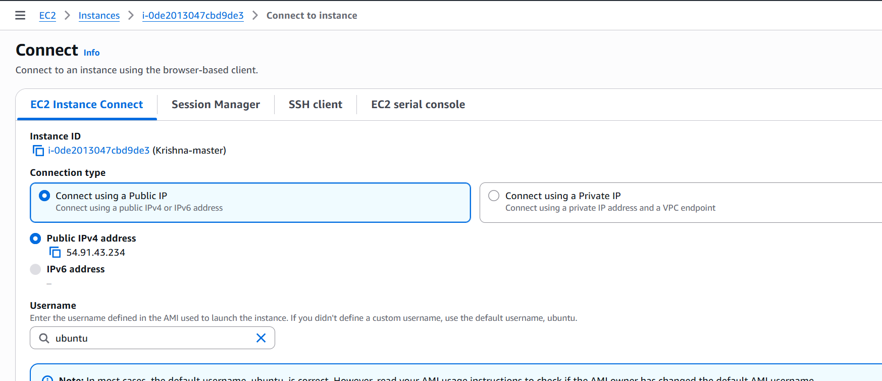

**b) Run basic commands**

**sudo su**

**apt update -y**

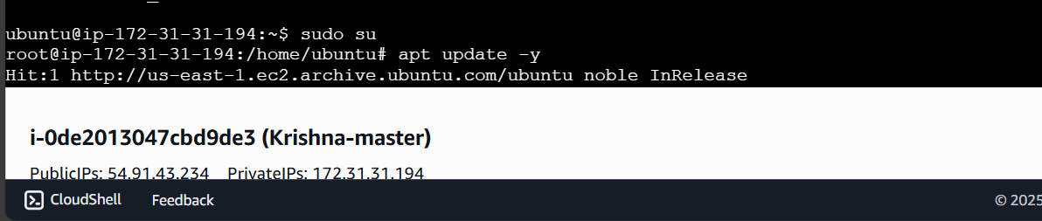

**c) Jenkins vi**

**Jenkins.sh**

**#!/bin/bash**

**# Install OpenJDK 17 JRE Headless**

**sudo apt install openjdk-17-jre-headless -y**

**# Download Jenkins GPG key**

**sudo wget -O /usr/share/keyrings/jenkins-keyring.asc \**

**https://pkg.jenkins.io/debian-stable/jenkins.io-2023.key**

**# Add Jenkins repository to package manager sources**

**echo "deb [signed-by=/usr/share/keyrings/jenkins-keyring.asc] \**

**https://pkg.jenkins.io/debian-stable binary/" | sudo tee \**

**/etc/apt/sources.list.d/jenkins.list > /dev/null**

**# Update package manager repositories**

**sudo apt-get update**

**# Install Jenkins**

**sudo apt-get install jenkins -y**

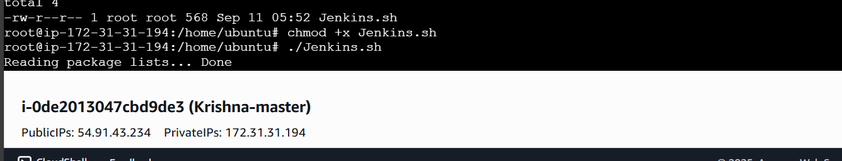

**press - esc :wq**

**give permissions and run the file**

**chmod +x** [**jenkin.sh**](http://jenkin.sh)

**./jenkins.sh**

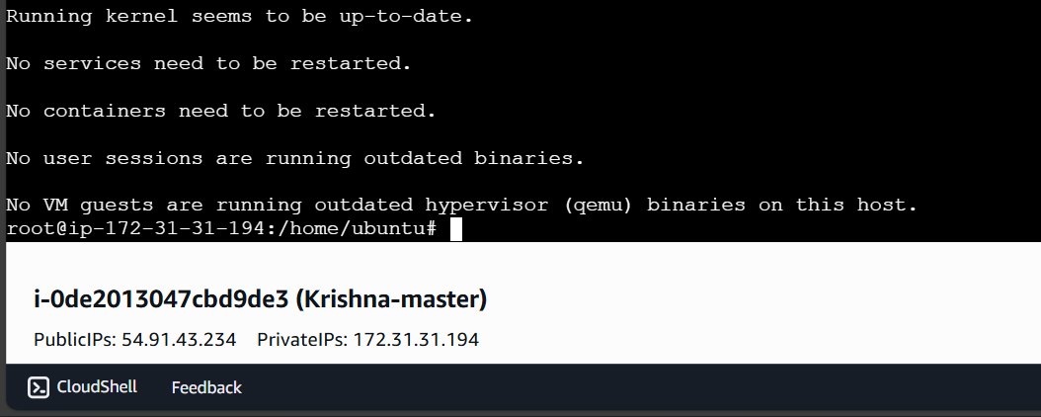

**Check for java and Jenkins working**

**java –version**

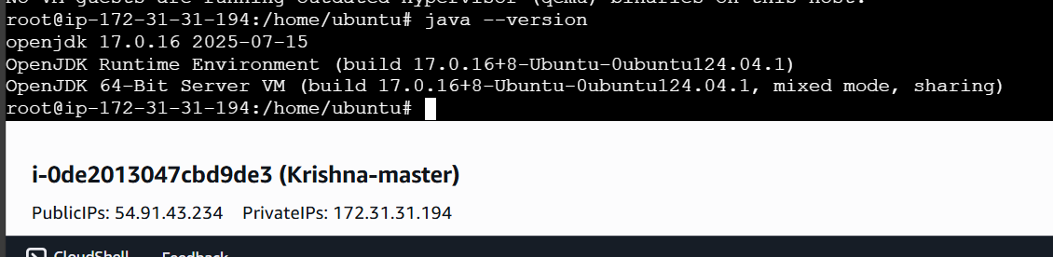

**sudo systemctl status jenkins**

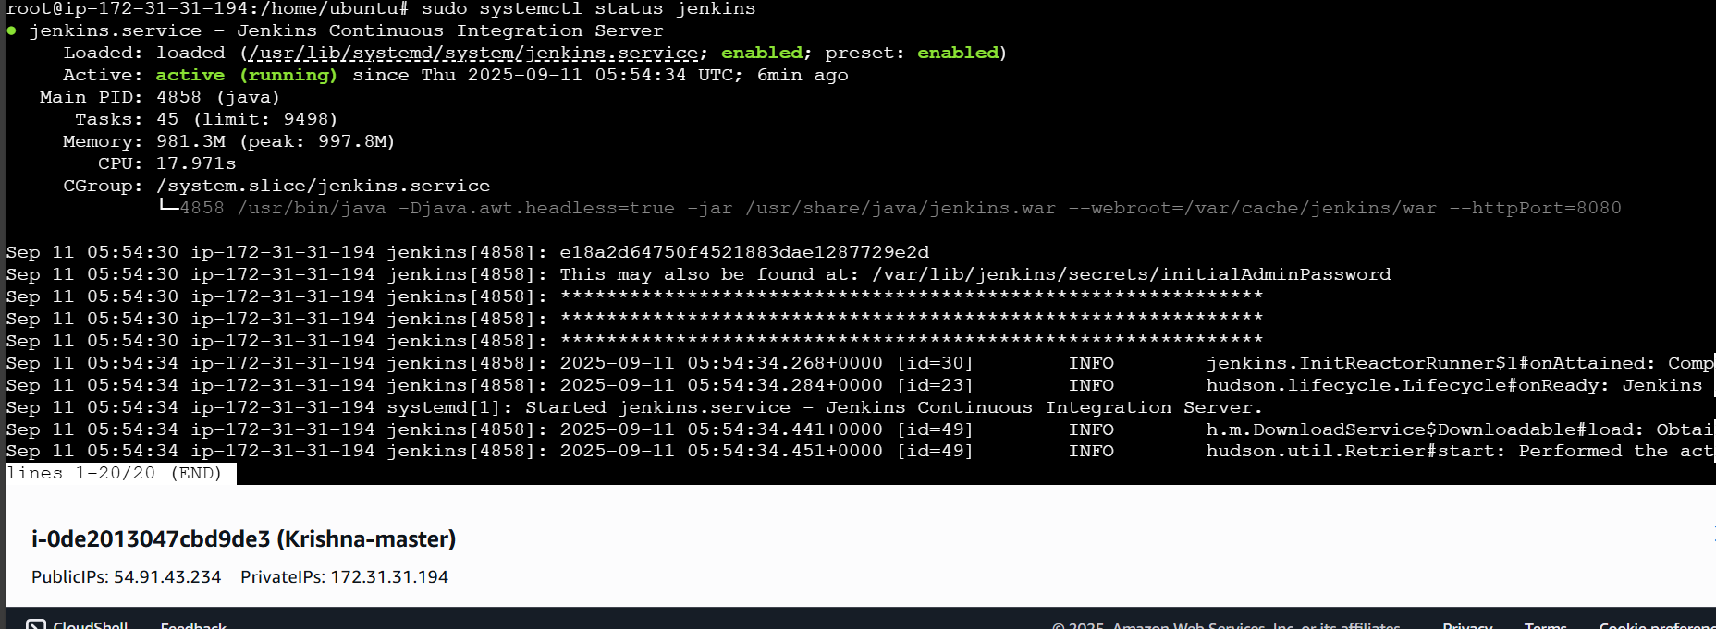

### **✅ Setup Jenkins**

**Open Port 8080 in the Jenkins Server  
 Access Jenkins by entering the following in your web browser:  
  
 http://<ip_address>:8080**

1. **Replace <ip_address> with the public IP address of your Jenkins server.**

**Retrieve the Initial Administrator Password  
 Run the following command to view the password:  
  
 cat /var/lib/jenkins/secrets/initialAdminPassword**

1. **Login to Jenkins  
    Copy the displayed password and paste it into the Administrator password field on the Jenkins setup page.**

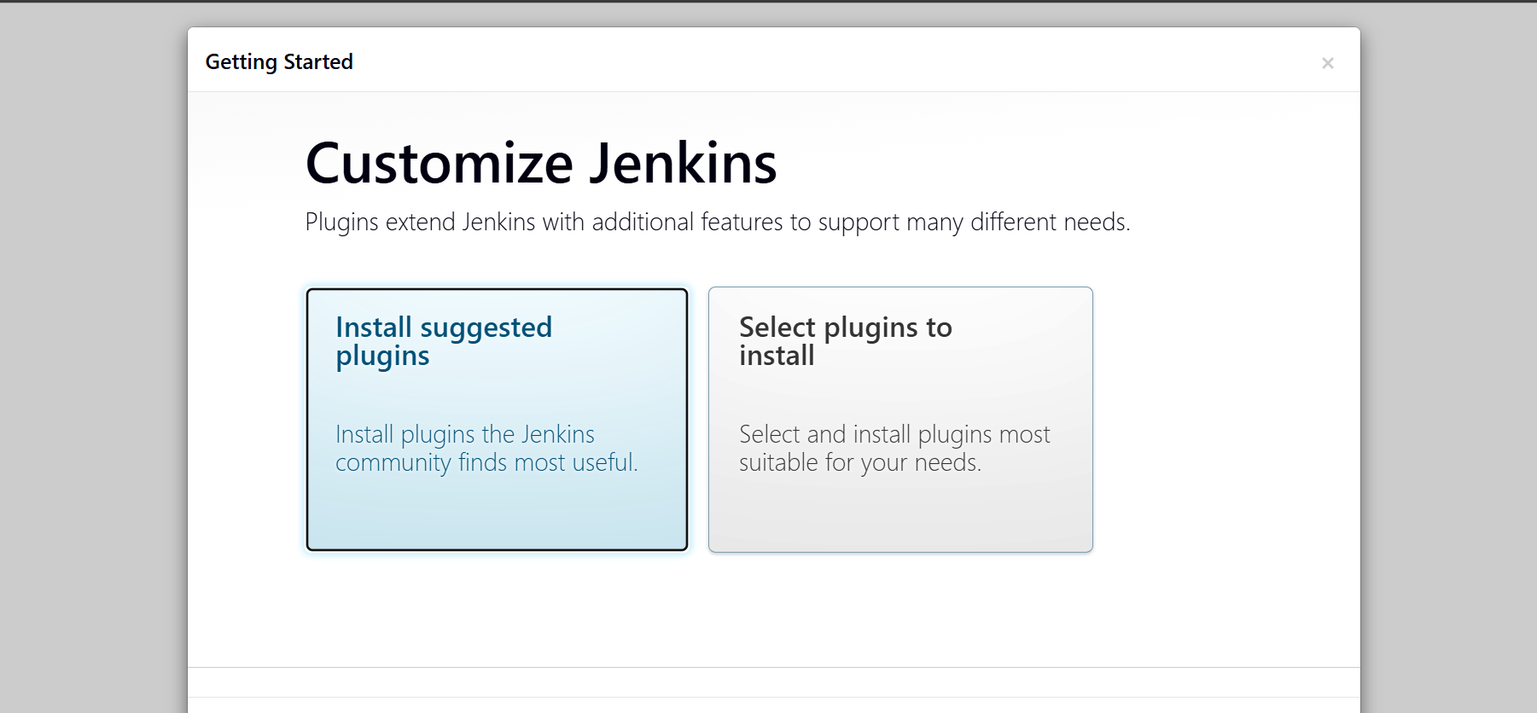

**Click on install all suggested plugins**

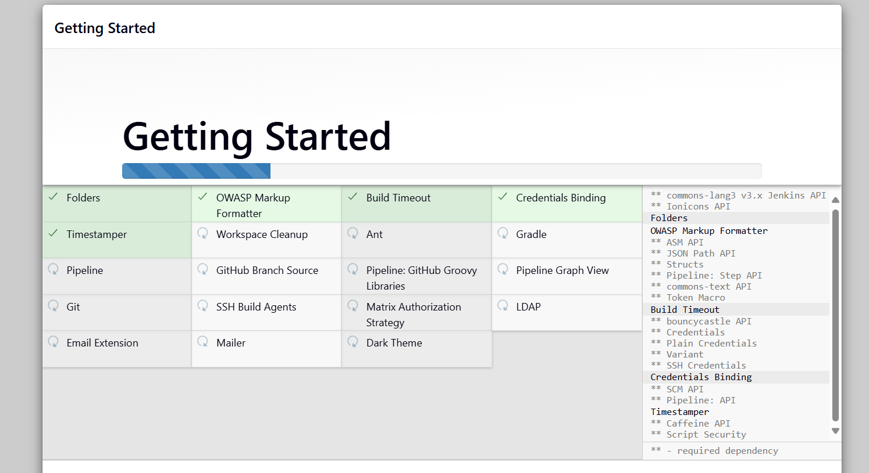

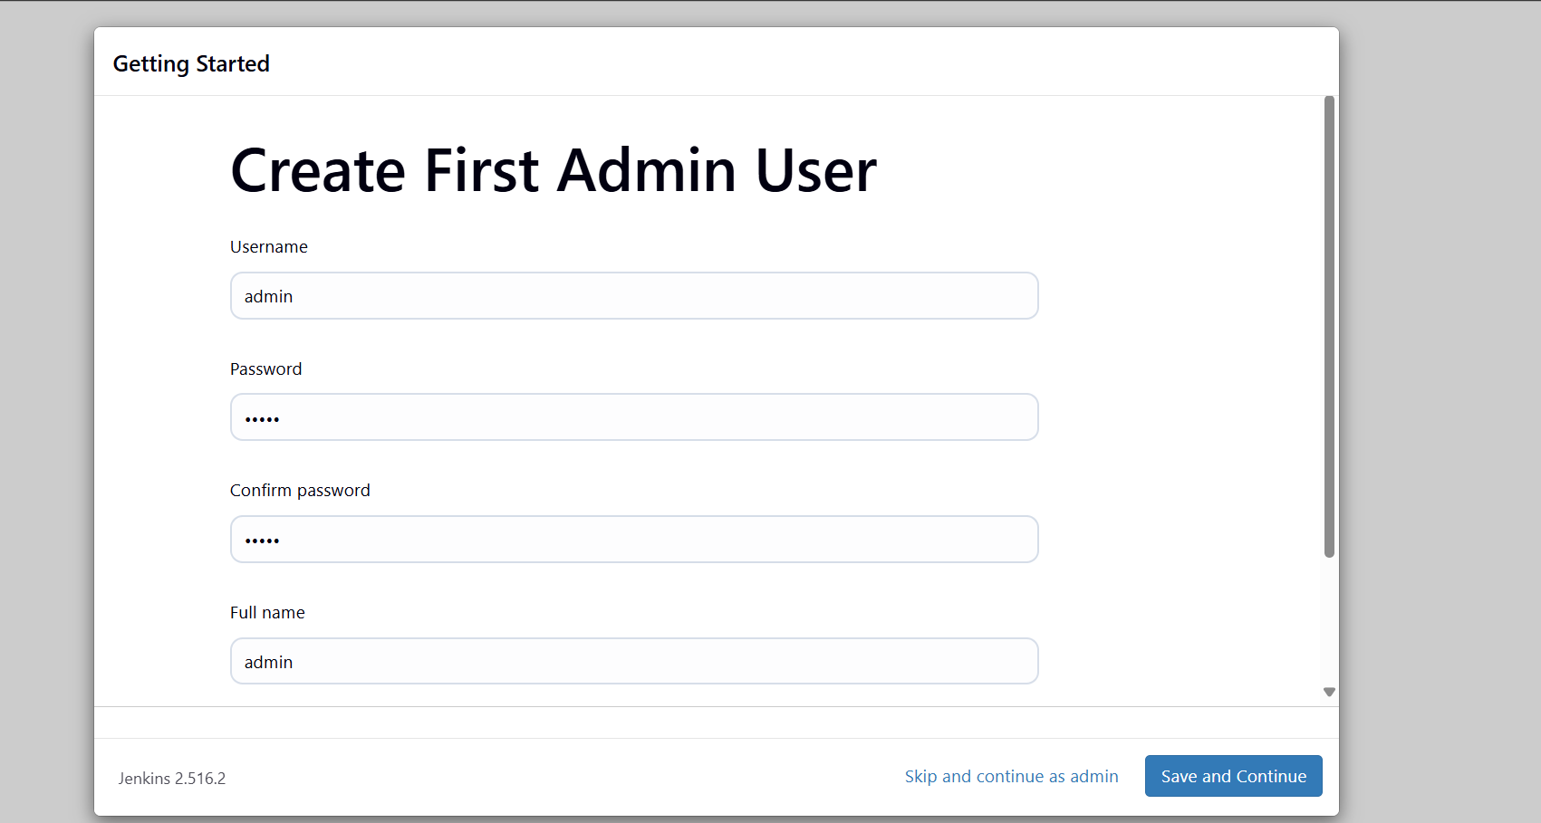

**d) Docker**

**#!/bin/bash**

**# Update package manager repositories**

**sudo apt-get update**

**# Install necessary dependencies**

**sudo apt-get install -y ca-certificates curl**

**# Create directory for Docker GPG key**

**sudo install -m 0755 -d /etc/apt/keyrings**

**# Download Docker's GPG key**

**sudo curl -fsSL https://download.docker.com/linux/ubuntu/gpg -o /etc/apt/keyrings/docker.asc**

**# Ensure proper permissions for the key**

**sudo chmod a+r /etc/apt/keyrings/docker.asc**

**# Add Docker repository to Apt sources**

**echo "deb [arch=$(dpkg --print-architecture) signed-by=/etc/apt/keyrings/docker.asc] \**

**https://download.docker.com/linux/ubuntu \**

**$(. /etc/os-release && echo \"$VERSION_CODENAME\") stable" | \**

**sudo tee /etc/apt/sources.list.d/docker.list > /dev/null**

**# Update package manager repositories**

**sudo apt-get update**

**# Install Docker packages**

**sudo apt-get install -y docker-ce docker-ce-cli containerd.io docker-buildx-plugin docker-compose-plugin**

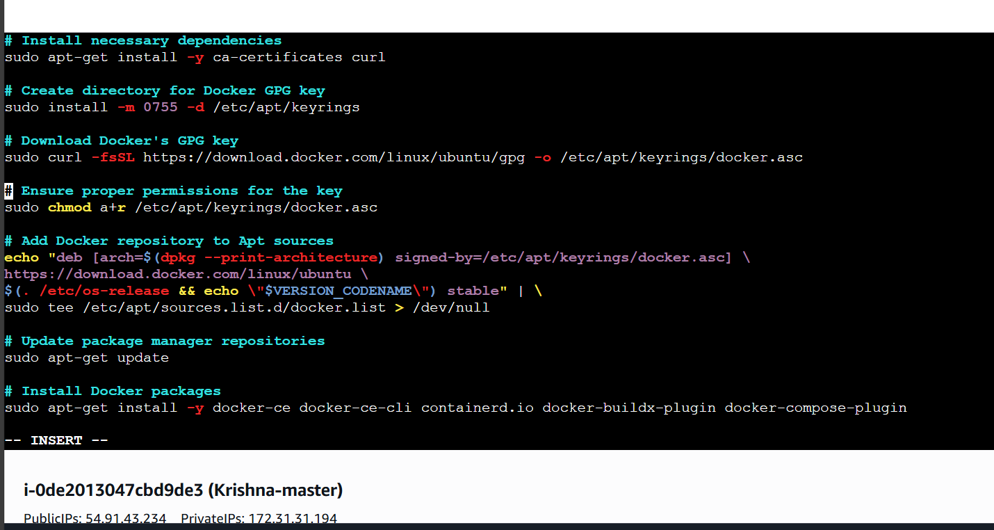

**press – esc :wq**

**give permission and run the file**

**chmod +x** [**docker.sh**](http://docker.sh)

**./**[**docker.sh**](http://docker.sh)

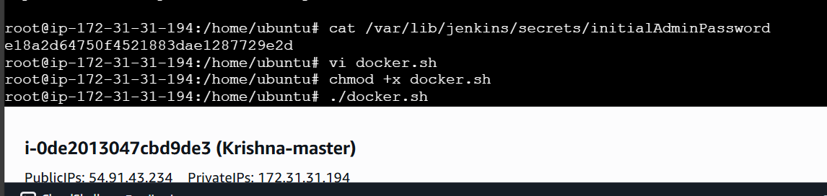

**Docker –version**

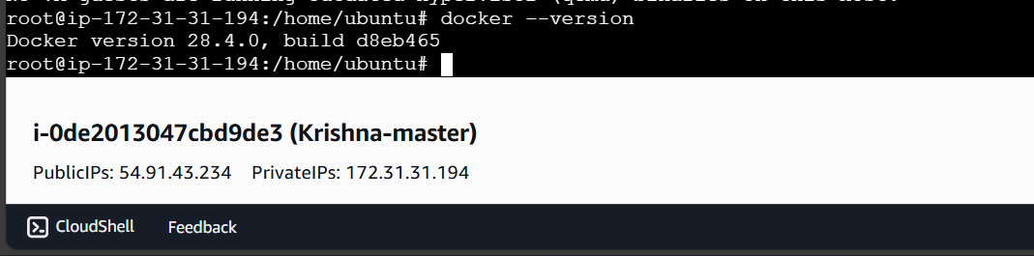

### **Pull a Default Docker Image**

### **Pull the hello-world image by running the following command: docker pull hello-world**

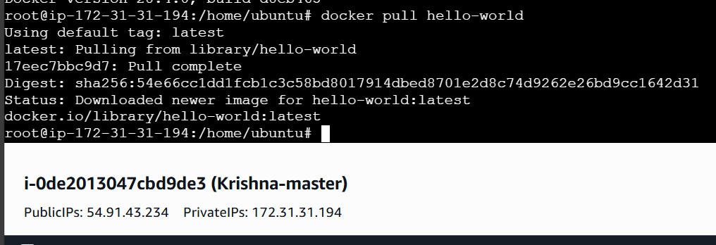

**1.If you see a permission denied error, execute the following command to allow Docker access:**

**sudo chmod 666 /var/run/docker.sock**

**2.After changing the permissions, pull the image again:  
docker pull hello-world**

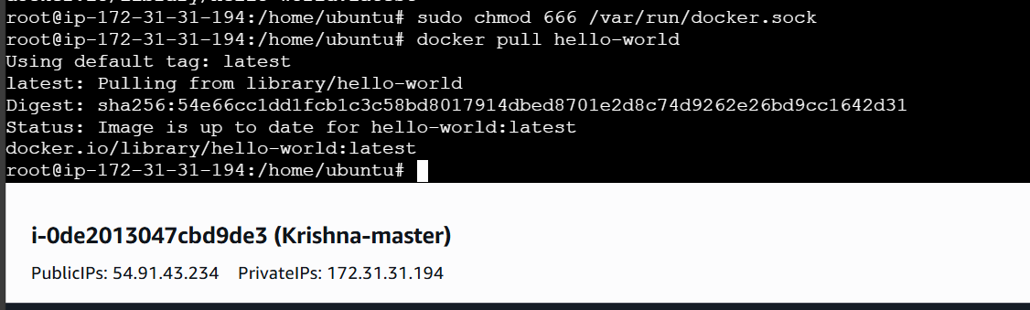

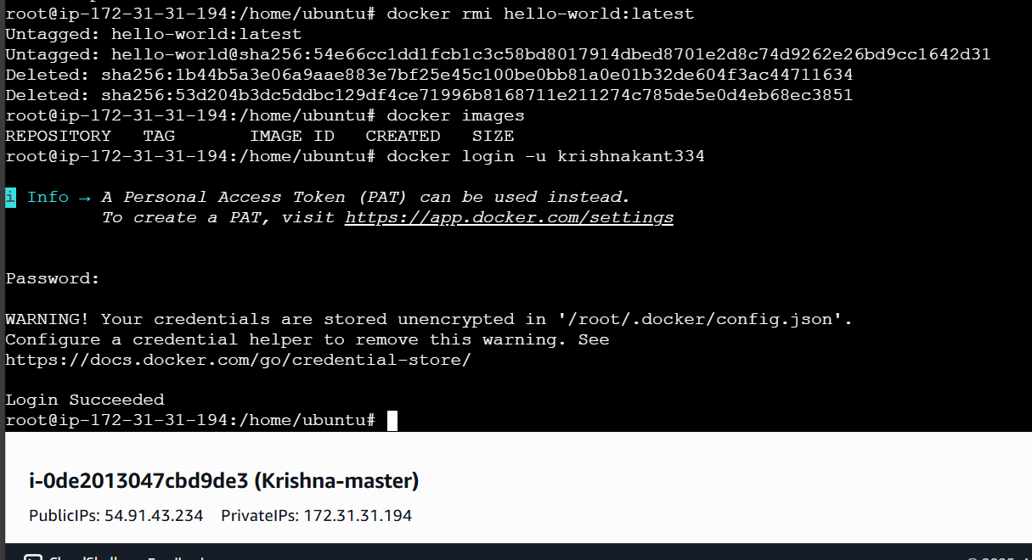

### **Remove the Docker Image and Login to Docker Hub**

**Remove the hello-world image by running:  
  
 docker rmi hello-world:latest**

1. **Verify that no images remain by running:  
     
    docker images**
2. **➤ The output should show no images.**
3. **Login to Docker Hub**
   * **Open Docker Hub in your browser and log in with your account.  
      ➤ This step is necessary; otherwise, the next steps may result in errors.**

**Login from the terminal by running:  
  
 docker login -u krishnakant334**

1. **➤ Press Enter, then type your Docker Hub password and press Enter.**

**e) AWS cli**

**First create Access key and Secret Access key**

**Go to security credentials**

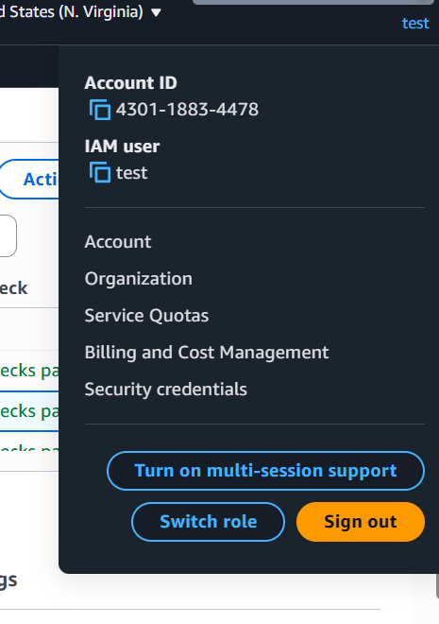

**Scroll down and click on create access key and create one since I am using sir’s account thus I will use the given access key**

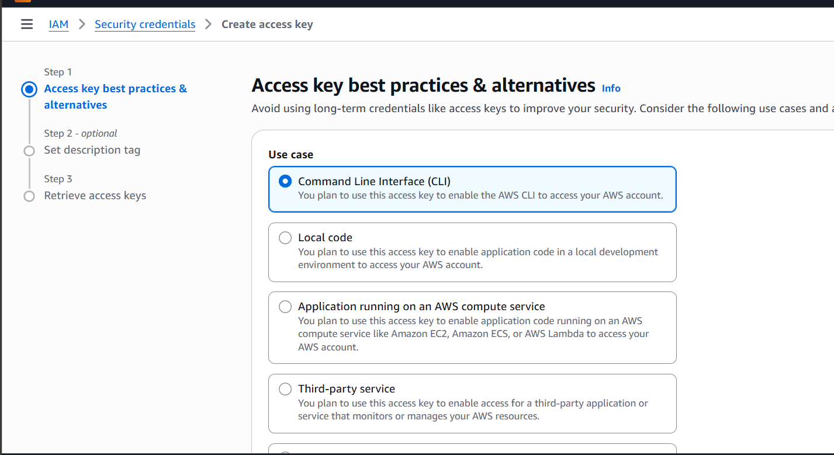

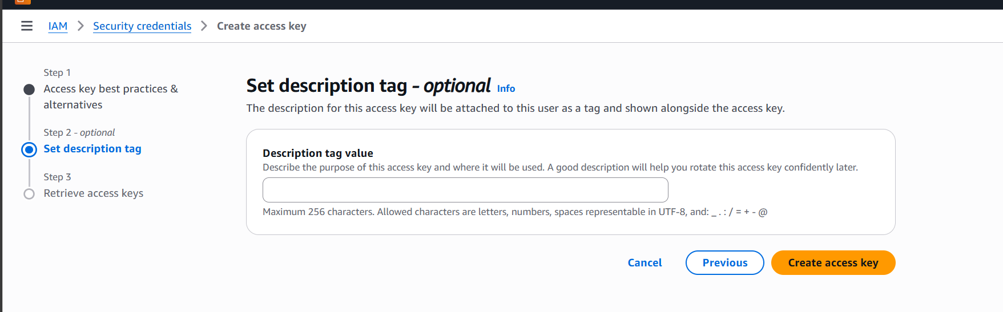

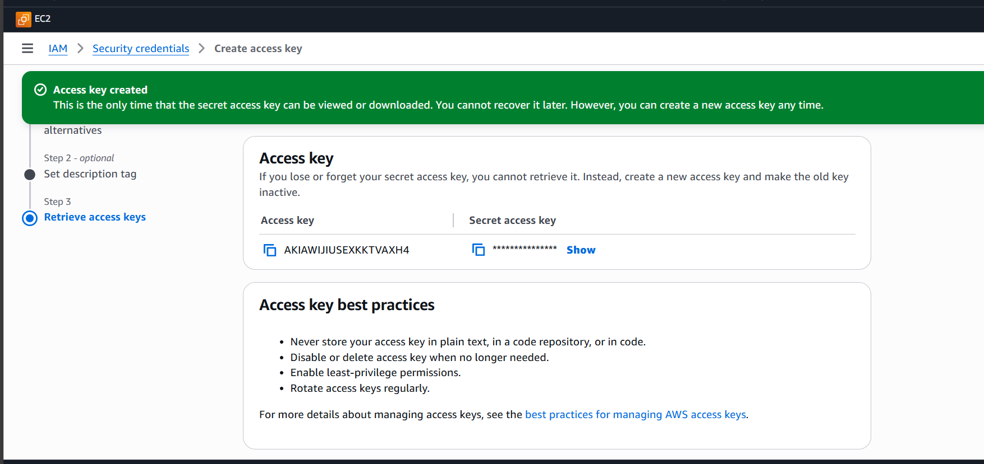

### **Install AWS CLI on the Server**

**Create the script file by running:  
  
 vi aws.sh**

**1.Add the following commands inside the file:  
  
 curl "https://awscli.amazonaws.com/awscli-exe-linux-x86_64.zip" -o "awscliv2.zip"**

**sudo apt install unzip -y**

**unzip awscliv2.zip**

**sudo ./aws/install**

**2.Save and exit the file:**

* + **Press Esc, type :wq, and press Enter.**

**2.Give execute permissions to the script:  
  
 chmod +x aws.sh**

**3.Run the script:  
  
 ./**[**aws.sh**](http://aws.sh)

### **Install AWS CLI using the downloaded package**

**Download the AWS CLI installer:  
  
 curl "https://awscli.amazonaws.com/awscli-exe-linux-x86_64.zip" -o "awscliv2.zip"**

**Install unzip if it’s not already installed:  
  
 sudo apt install unzip -y**

**Extract the AWS CLI installer:  
  
 unzip awscliv2.zip**

1. **Run the installation script:  
     
    sudo ./aws/install**

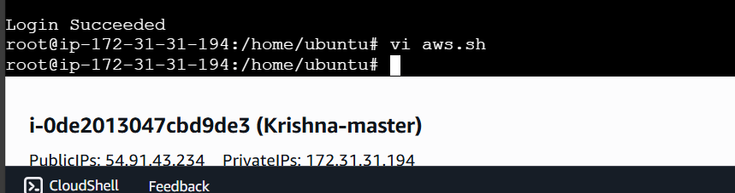

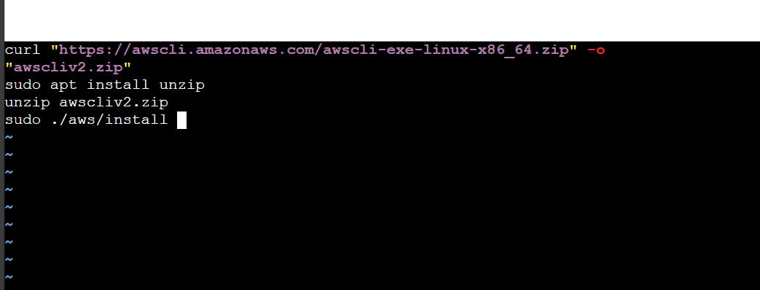

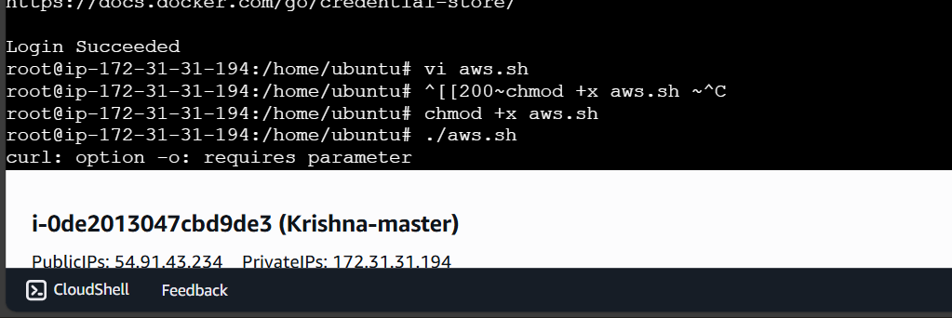

**Aws version check**

**aws –version**

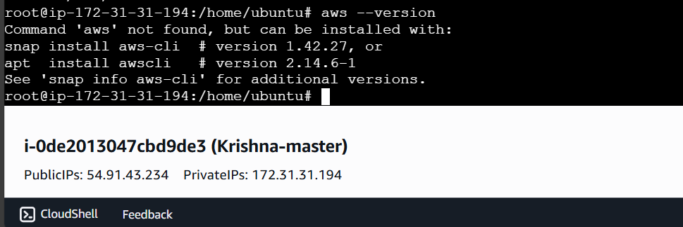

### **Configure AWS CLI**

**Run the following command to start AWS configuration:  
  
 aws configure**

**Enter the requested details:**

* + **AWS Access Key ID: *Enter your access key***
  + **AWS Secret Access Key: *Enter your secret key***
  + **Default region name: <your_working_region>**
  + **Default output format: json**

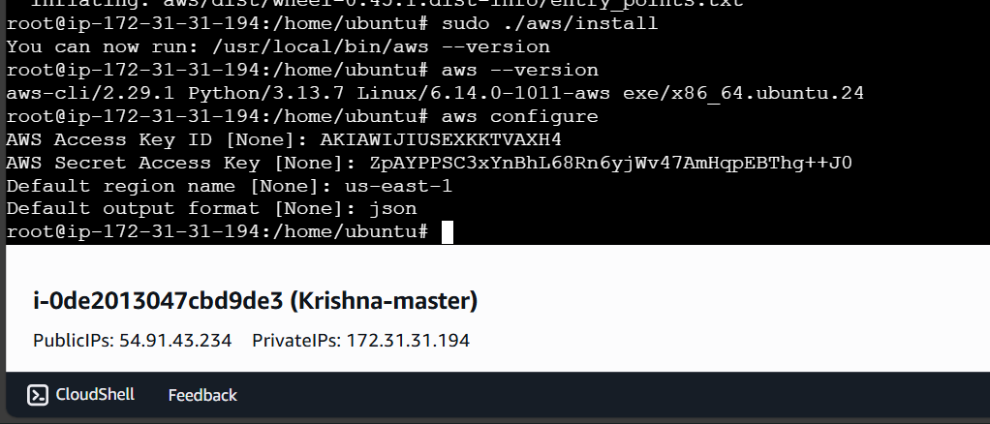

### **Install kubectl**

**Create the script file by running:  
  
 vi kubectl.sh**

**Add the following commands inside the file:  
  
 curl -o kubectl https://amazon-eks.s3.us-west-2.amazonaws.com/1.19.6/2021-01-05/bin/linux/amd64/kubectl**

**chmod +x ./kubectl**

**sudo mv ./kubectl /usr/local/bin**

**kubectl version --short --client**

1. **Save and exit the file:**
   * **Press Esc, type :wq, and press Enter.**

**Give execute permissions to the script:  
  
 chmod +x kubectl.sh**

1. **Run the script:  
     
    ./**[**kubectl.sh**](http://kubectl.sh)

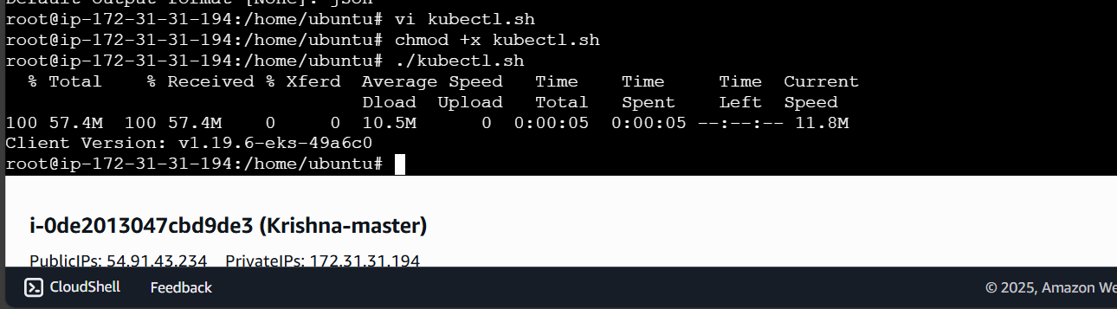

### **Install eksctl**

**Create the script file by running:  
  
 vi eksctl.sh**

**Add the following commands inside the file:  
  
 curl --silent --location "https://github.com/weaveworks/eksctl/releases/latest/download/eksctl_$(uname -s)_amd64.tar.gz" | tar xz -C /tmp**

**sudo mv /tmp/eksctl /usr/local/bin**

**eksctl version**

1. **Save and exit the file:**
   * **Press Esc, type :wq, and press Enter.**

**Give execute permissions to the script:  
  
 chmod +x eksctl.sh**

1. **Run the script:  
     
    ./eksctl.sh**

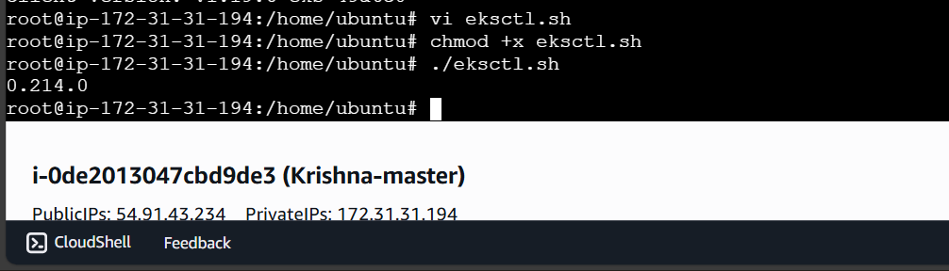

### **Install Ansible**

**Create the script file by running:  
  
 vi ansible.sh**

**Add the following commands inside the file:  
  
 sudo add-apt-repository --yes --update ppa:ansible/ansible**

**sudo apt install ansible -y**

1. **Save and exit the file:**
   * **Press Esc, type :wq, and press Enter.**

**Give execute permissions to the script:  
  
 chmod +x ansible.sh**

**Run the script:  
  
 ./ansible.sh**

1. **Check the installed version of Ansible:  
     
    ansible --version**

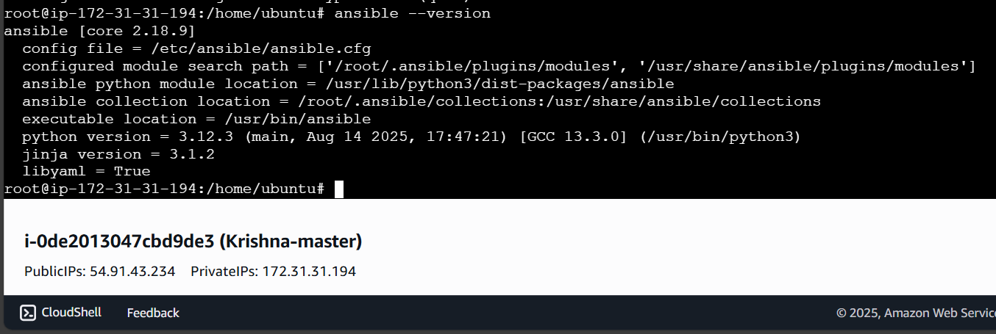

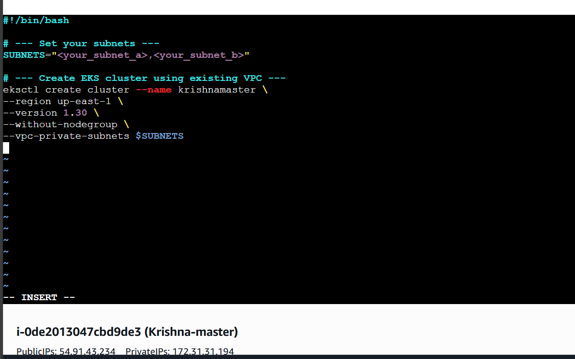

**#!/bin/bash**

**# --- Set your subnets ---**

**SUBNETS="subnet-09527e09d2b636418,subnet-01dfc86302e426722"**

**# --- Create EKS cluster using existing VPC ---**

**eksctl create cluster --name krishnamaster \**

**--region us-east-1 \**

**--version 1.30 \**

**--without-nodegroup \**

**--vpc-private-subnets $SUBNETS**

### **Instructions**

**Save this script to cluster.sh:  
  
 vi cluster.sh**

1. **Paste the above content.**
2. **Save and exit (Esc, type :wq, press Enter).**

**Make the script executable:  
  
 chmod +x cluster.sh**

1. **Run the script:  
     
    ./cluster.sh**

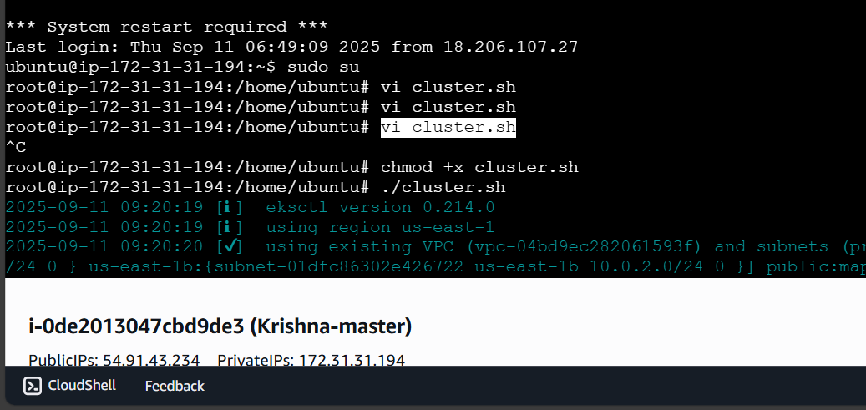

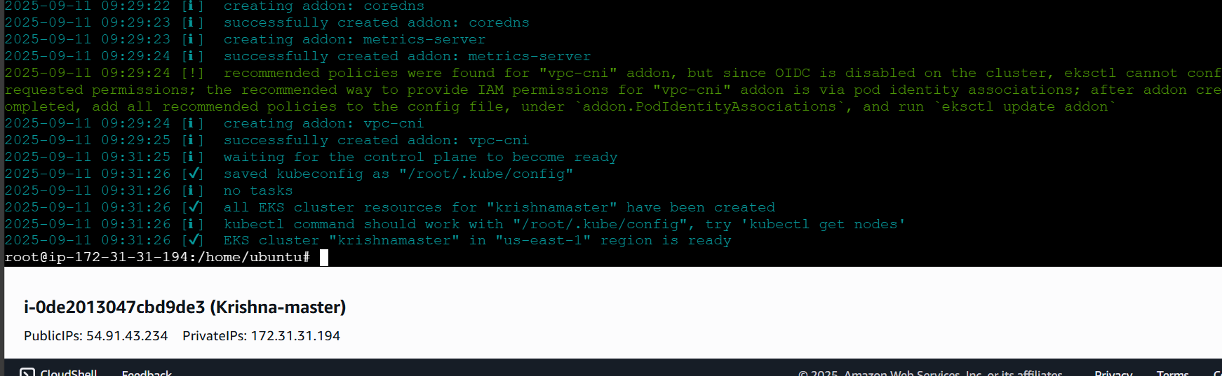

#### **b) Associate IAM OIDC Provider**

**1.Open the script file:  
  
 vi ekassociation.sh**

**2.Add the following content inside the file:  
  
 eksctl utils associate-iam-oidc-provider \**

**--region up-east-1 \**

**--cluster krishnamaster \**

**--approve**

**3.Save and exit the file.**

**4.Give execute permission and run the script:  
  
 chmod +x ekassociation.sh**

**./**[**ekassociation.sh**](http://ekassociation.sh)

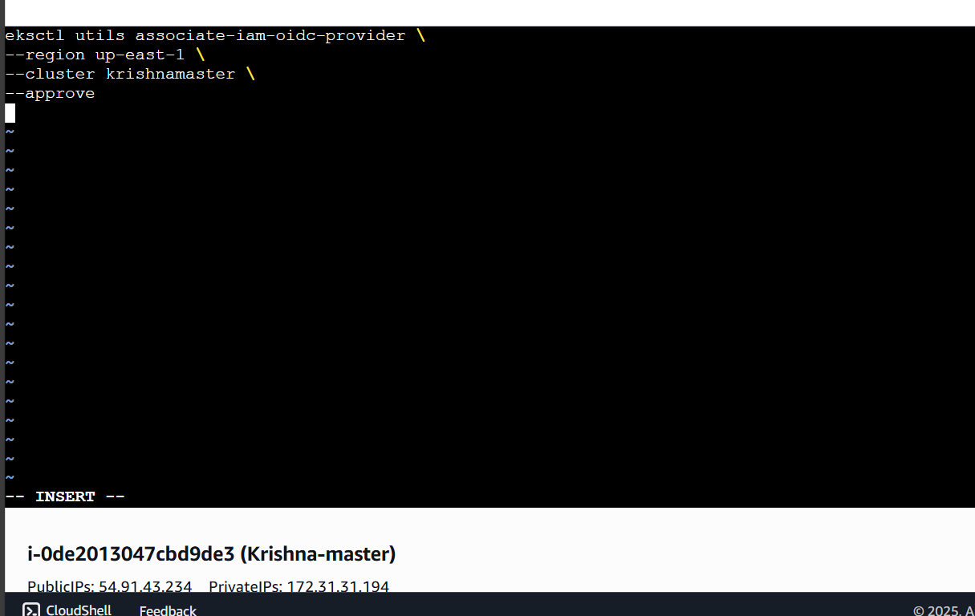

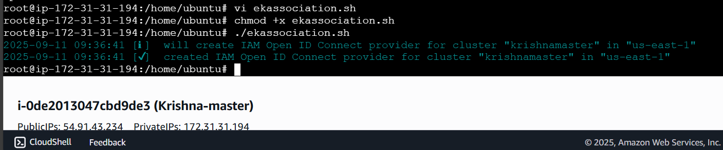

**#!/bin/bash**

**eksctl create nodegroup \**

**--cluster krishnamaster \**

**--region us-east-1 \**

**--name node2 \**

**--node-type t3.medium \**

**--nodes 2 \**

**--nodes-min 1 \**

**--nodes-max 2 \**

**--node-volume-size 20 \**

**--ssh-access \**

**--ssh-public-key <your_key_name> \**

**--managed \**

**--asg-access \**

**--external-dns-access \**

**--full-ecr-access \**

**--appmesh-access \**

**--alb-ingress-access \**

**--node-private-networking \**

**--subnet-ids subnet-09527e09d2b636418,subnet-01dfc86302e426722 \**

**--tags "Environment=dev"**

### **instructions**

**Save this script as createnode.sh:  
  
 vi createnode.sh**

1. **Paste the content above, then save and exit (Esc, :wq, Enter).**

**Make it executable:  
  
 chmod +x createnode.sh**

1. **Run the script:  
     
    ./**[**createnode.sh**](http://createnode.sh)

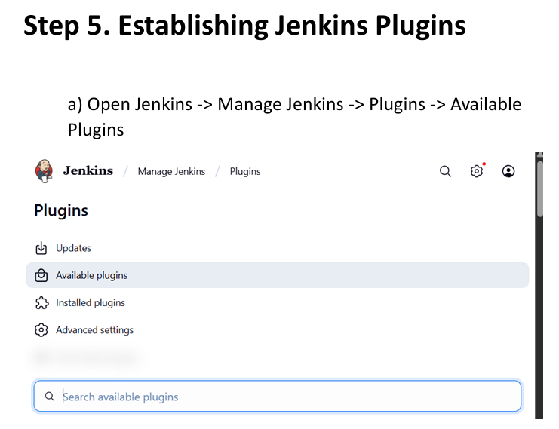

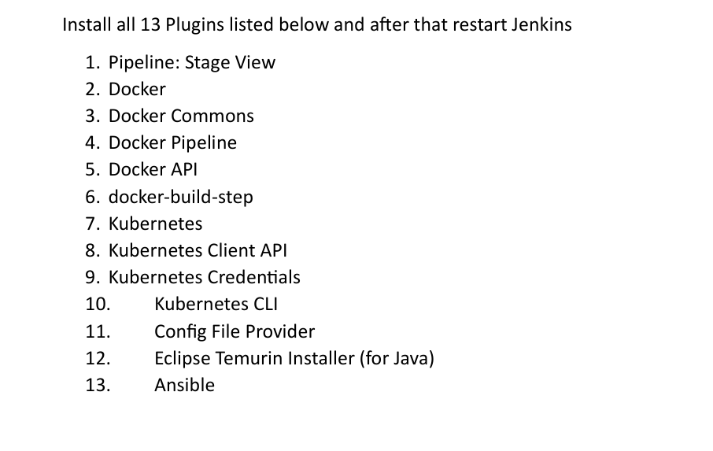

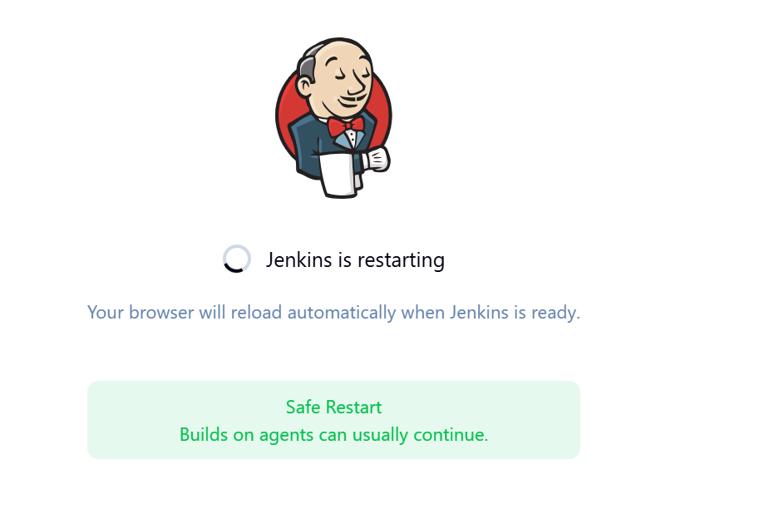

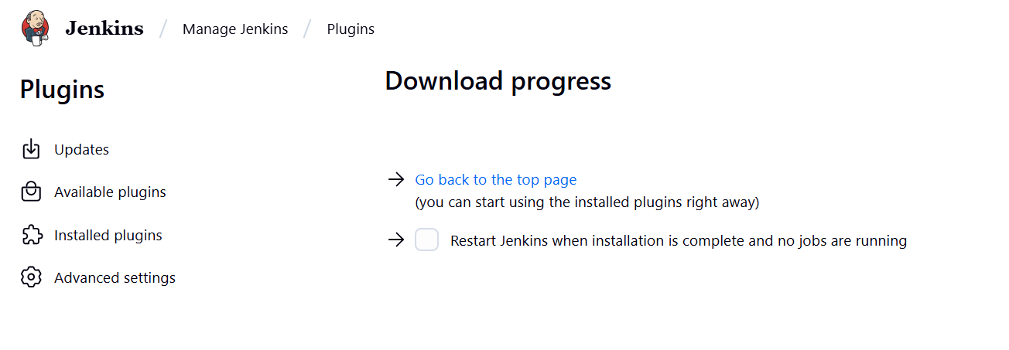

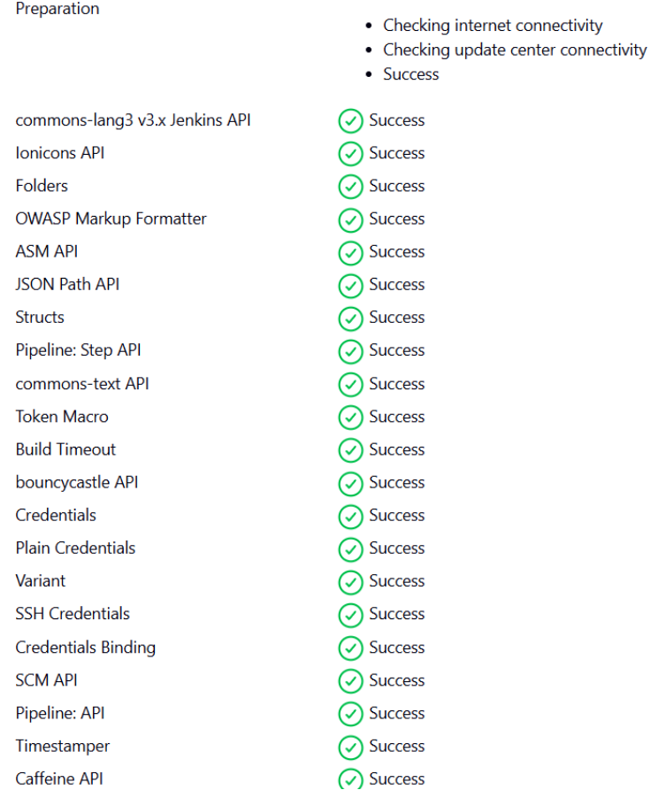

**after installation check on Restart option**

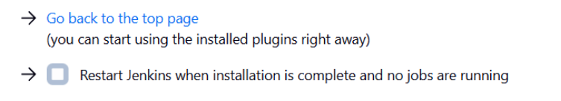

**b) Go to Manage jenikns -> Credentials (Under security) ->click global -> Add credentials**

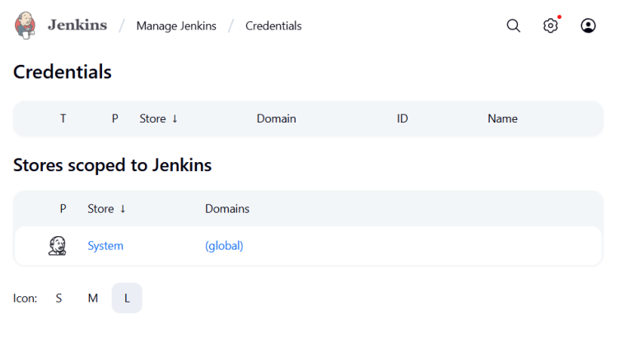

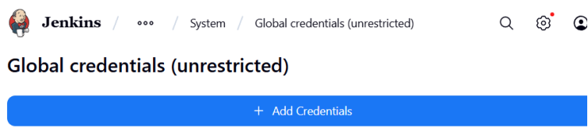

**Make below changes**

**User name = your docker username**

**Password = your docker hub password**

**Id = docker**

**Description = docker**

**Click create**

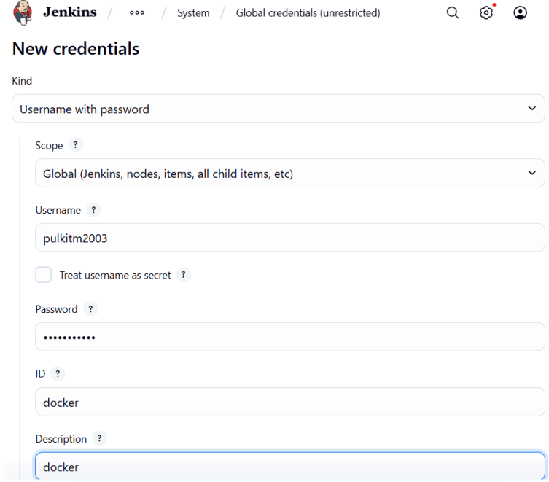

**Add global credentials for ansible too**

**Kind : SSH Username with private key**

**Scope : Global**

**ID : ansible-ssh**

**Username : ubuntu**

**Click on Private key enter directly and enter the private key used to make master ec2**

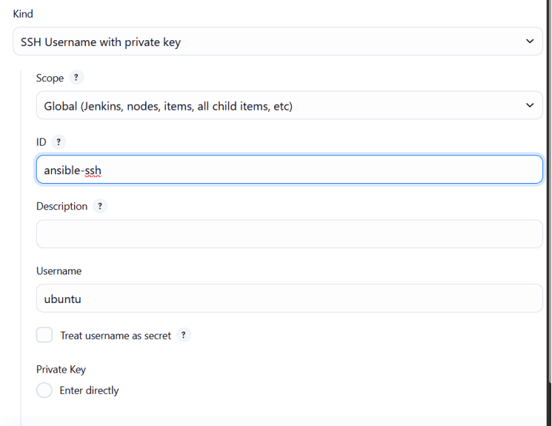

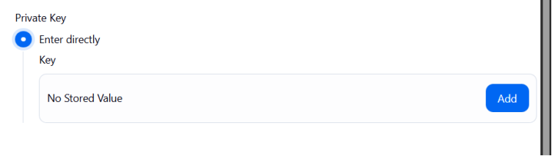

**Add Credentials for AWS access key**

**Kind : Secret key**

**Scope : Global**

**Secret : <add_accesskey>**

**ID : aws-access-key**

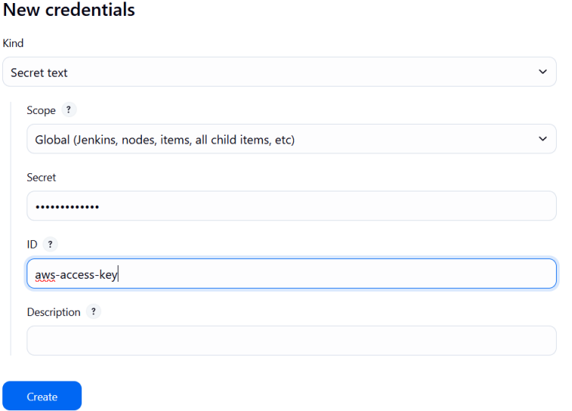

**Add Credentials for AWS Secret access key**

**Kind : Secret key**

**Scope : Global**

**Secret : <add_Secret_accesskey>**

**ID : aws-secret-key**

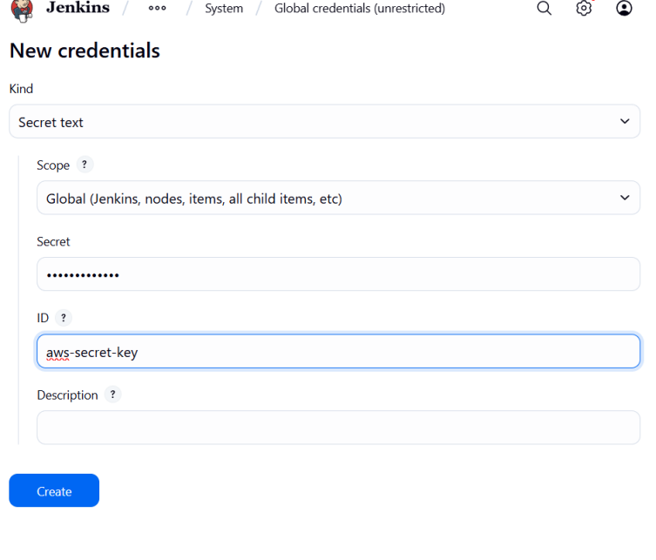

**Click on create**

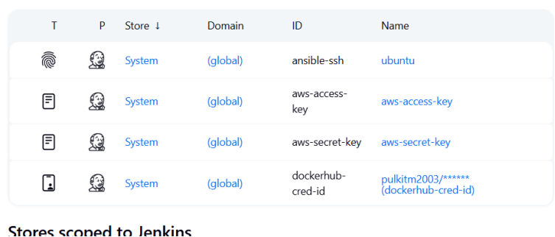

**c) go to -> Manage Jenkins -> Tools (under system configuration) ->**

**click on Add jdk  
name: jdk17  
select install automatically**

**under installer dropdown  
select “install from adoptium.net”  
 version? : select jdk-17.0.8.1+1 version  
-----------------------------------------------------------------------------  
add docker  
 name: docker**

**select install automatically  
add installer  
Download from docker.com  
--------------------------------------------------------------------------**

**add ansible  
name: ansible**

**leave as it is  
--------------------------------------------------------------------------  
  
click on apply and save**

**Step 6. Creating Dynamic Inventory**

**a) Give different names**

**since all our nodes have same names thus we need to give them different names to differentiate here we will use the tag we gave earlier Environment = dev**

**vi tags.sh**

**# Fetch instance IDs that match Environment=dev and Role=web**

**instance_ids=$(aws ec2 describe-instances \**

**--filters "Name=tag:Environment,Values=dev" "Name=instance-state-name,Values=running" \**

**--query 'Reservations[*].Instances[*].InstanceId' \**

**--output text)**

**# Sort instance IDs deterministically**

**sorted_ids=($(echo "$instance_ids" | tr '\t' '\n' | sort))**

**# Rename instances sequentially**

**counter=1**

**for id in "${sorted_ids[@]}"; do**

**name="<name_you_want>-$(printf "%02d" $counter)"**

**echo "Tagging $id as $name"**

**aws ec2 create-tags --resources "$id" \**

**--tags Key=Name,Value="$name"**

**((counter++))**

**done**

**press esc:wq**

**give permission and run file**

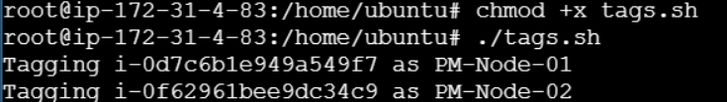

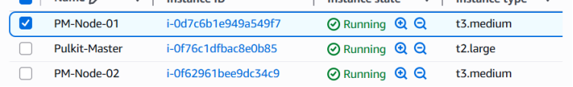

**b) Create Ansible key**

**ssh-keygen -t rsa -b 4096 -C "Ansible-Master"**

**press enter 3 times**

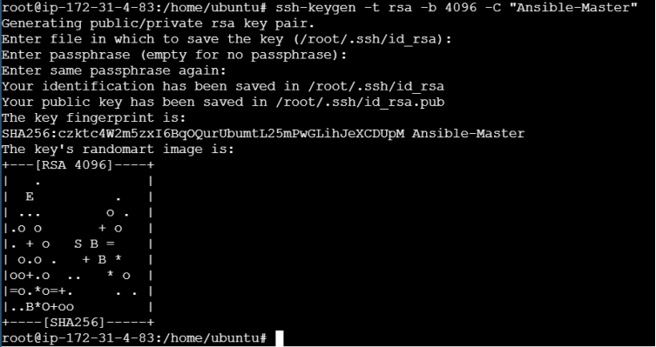

**c) Creating Yaml file that will hold IP address of node**

**mkdir inventory**

**vi inventory/aws_ec2.yaml**

**plugin: amazon.aws.aws_ec2**

**regions:**

**- <your_region_name>**

**filters:**

**tag:Environment: dev**

**instance-state-name: running**

**compose:**

**ansible_host: public_ip_address**

**keyed_groups:**

**- key: tags.Name**

**prefix: name**

**- key: tags.Environment**

**prefix: env**

**to test run this command**

**ansible-inventory -i inventory/aws_ec2.yaml –graph**

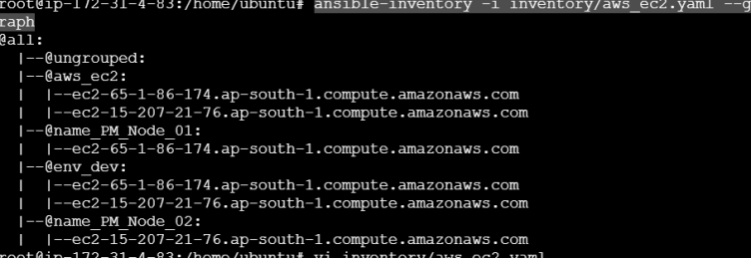

**Step 7. Connecting Ansible Master - Node**

**a) Creating Ansible Environment**

**We are setting up separate environment to isolate Ansible dependencies**

**Install venv module if not already present :**

**sudo apt install python3-venv -y**

**Create a virtual environment :**

**python3 -m venv ansible-env**

**Activate it :**

**source ansible-env/bin/activate**

**we can see now we have entered into ansible environment**



**Install required Python packages :**

**pip install boto3 botocore docker**

**b) Creating Key file**

**Open the key pair file in notepad and copy its content**

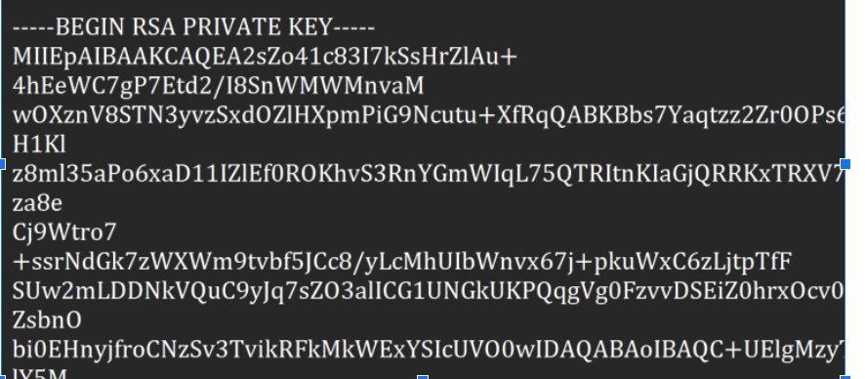

**Paste this content in file below**

**vi Krishna-New-kp.pem**

**(name should be same as key pair used to create master and nodes )**

**After pasting key value here press – esc:wq**

**Give read only permission**

**Chmod 400 Krishna-New-kp.pem**

**c) Give over ride permission**

**since while adding key in nodes nodes require permission as yes but we cannot open each node and give it permission as there are multiple nodes thus we will over ride those permissions**

**vi ansible.cfg**

**[defaults]**

**inventory = ./inventory/aws_ec2.yaml**

**host_key_checking = False**

**[ssh_connection]**

**ssh_args = -o StrictHostKeyChecking=no -o UserKnownHostsFile=/dev/null**

**d) Script to connect Nodes and Master**

**vi copy-public-key.sh**

**#!/bin/bash**

**# Define vars**

**PEM_FILE="Krishna-New-kp.pem"**

**PUB_KEY=$(cat ~/.ssh/id_rsa.pub)**

**USER="ec2-user" # Since nodegroup is Linux**

**INVENTORY_FILE="inventory/aws_ec2.yaml"**

**# Extract hostnames/IPs from dynamic inventory**

**HOSTS=$(ansible-inventory -i $INVENTORY_FILE --list | jq -r '._meta.hostvars | keys[]')**

**for HOST in $HOSTS; do**

**echo "Injecting key into $HOST"**

**ssh -o StrictHostKeyChecking=no -i $PEM_FILE $USER@$HOST "**

**mkdir -p ~/.ssh && \**

**echo \"$PUB_KEY\" >> ~/.ssh/authorized_keys && \**

**chmod 700 ~/.ssh && \**

**chmod 600 ~/.ssh/authorized_keys**

**"**

**done**

**give permission and run file**

**chmod +x copy-public-key.sh**

**./copy-public-key.sh**

**Step 8. Final Deployment Stage**

**a) Give Jenkins Permission to ansible environment**

**sudo chown -R jenkins:jenkins /home/ubuntu/ansible-env**

**sudo chmod -R 755 /home/ubuntu/ansible-env**

**sudo chmod 755 /home/ubuntu  
  
 verify**

**sudo -u jenkins ls -l /home/ubuntu/ansible-env/bin/activate**

**sudo -u jenkins bash -c "source/home/ubuntu/ansible-env/bin/activate && echo Activated"**



a) Give docker permission in ansible environment

sudo usermod -aG docker jenkins

sudo systemctl restart Jenkins

b) Exiting Ansible environment after checking the requirements

# Inside ansible-env

source /home/ubuntu/ansible-env/bin/activate

pip install --upgrade pip

pip install ansible boto3 botocore kubernetes

ansible-galaxy collection install kubernetes.core

deactivate

c) Making Kubernetes deployment files

make the below files on both ssh and Github

On Github create a new k8s folder and makes files in it

Make files on forked repository

mkdir k8s

vi k8s/deployment.yaml

apiVersion: apps/v1

kind: Deployment

metadata:

name: apache-deployment

spec:

replicas: 2

selector:

matchLabels:

app: apache

template:

metadata:

labels:

app: apache

spec:

containers:

- name: apache

image: <your_docker_id>/apachewebsite:latest # Your Docker Hub image

ports:

- containerPort: 80

vi k8s/service.yaml

apiVersion: v1

kind: Service

metadata:

name: apache-service

spec:

type: LoadBalancer

selector:

app: apache

ports:

- protocol: TCP

port: 80

targetPort: 80

d) Ansible Deployment file make it on Github on Master branch

name of file deploy-k8s.yaml

- name: Deploy Apache website to EKS

hosts: localhost

connection: local

tasks:

- name: Ensure AWS CLI is configured for EKS

command: aws eks update-kubeconfig --name <your_cluster_name> --region <your_region_name>

- name: Deploy Apache Deployment

kubernetes.core.k8s:

state: present

namespace: default

src: k8s/deployment.yaml

- name: Deploy Apache Service

kubernetes.core.k8s:

state: present

namespace: default

src: k8s/service.yaml

- name: Verify deployment pods

command: kubectl get pods -o wide

register: pod_status

- debug:

var: pod_status.stdout_lines

e) Make Jenkins file on Github

name of file Jenkinsfile

pipeline {

agent any

environment {

DOCKER_IMAGE = "<docker_id>/apachewebsite:latest"

}

stages {

stage('Checkout SCM') {

steps {

checkout scm

}

}

stage('Docker Build & Push') {

steps {

script {

withDockerRegistry([credentialsId: 'dockerhub-cred-id', url: 'https://index.docker.io/v1/']) {

sh '''

echo "Building Docker image..."

docker build -t $DOCKER_IMAGE .

echo "Pushing Docker image to DockerHub..."

docker push $DOCKER_IMAGE

'''

}

}

}

}

stage('Prepare Kubernetes Manifests') {

steps {

sh '''

echo "Copying Kubernetes manifests into Jenkins workspace..."

mkdir -p k8s

cp /home/ubuntu/k8s/service.yaml k8s/service.yaml

cp /home/ubuntu/k8s/deployment.yaml k8s/deployment.yaml

'''

}

}

stage('Deploy to EKS via Ansible') {

steps {

withCredentials([

string(credentialsId: 'aws-access-key', variable: 'AWS_ACCESS_KEY_ID'),

string(credentialsId: 'aws-secret-key', variable: 'AWS_SECRET_ACCESS_KEY')

]) {

sh '''

echo "Exporting AWS credentials..."

export AWS_ACCESS_KEY_ID=$AWS_ACCESS_KEY_ID

export AWS_SECRET_ACCESS_KEY=$AWS_SECRET_ACCESS_KEY

export AWS_DEFAULT_REGION=ap-south-1

echo "Activating Ansible virtual environment..."

. /home/ubuntu/ansible-env/bin/activate

echo "Running Ansible playbook for Kubernetes deployment..."

ansible-playbook deploy-k8s.yaml

'''

}

}

}

stage('Verify Deployment') {

steps {

echo "Stage skipped if deployment failed"

}

}

}

post {

success {

echo "✅ Deployment succeeded!"

}

failure {

echo "❌ Deployment failed!"

}

}

}

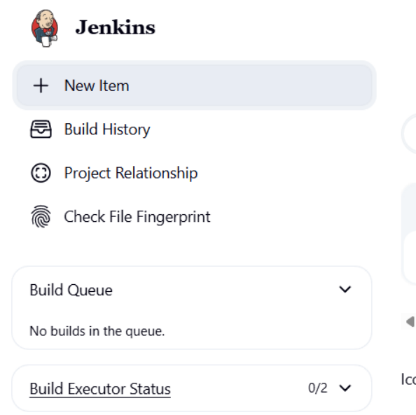

Enter name -> Select Pipeline option -> click on OK

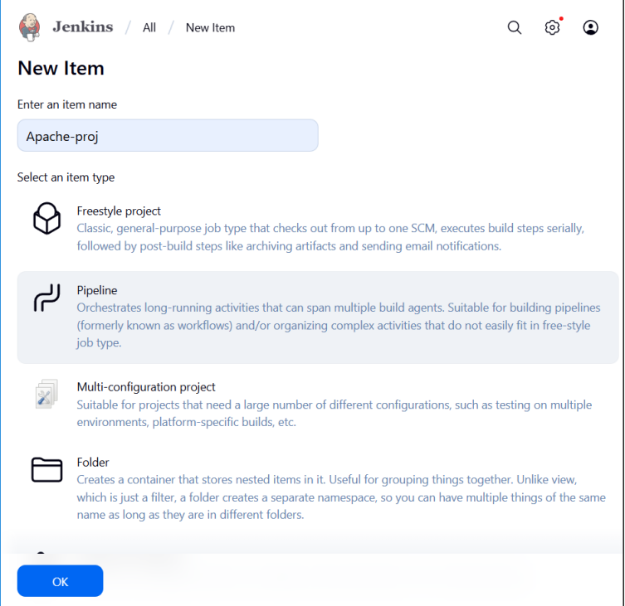

Scroll down to Pipeline section

Select Defination -> Pipeline script from SCM

Select SCM as Git

Under Repositories Add <your repository url>

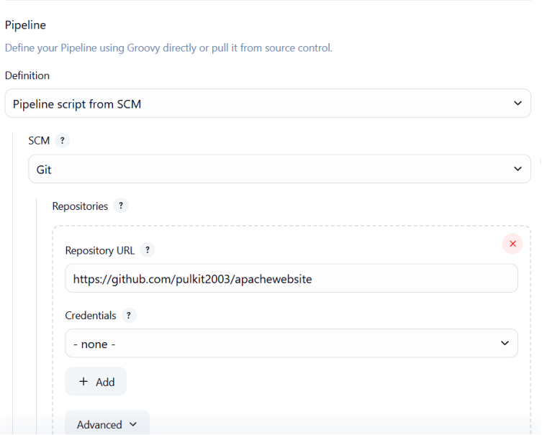

Select Master as Branch

Script path as Jenkinfile

Then click Apply and Save

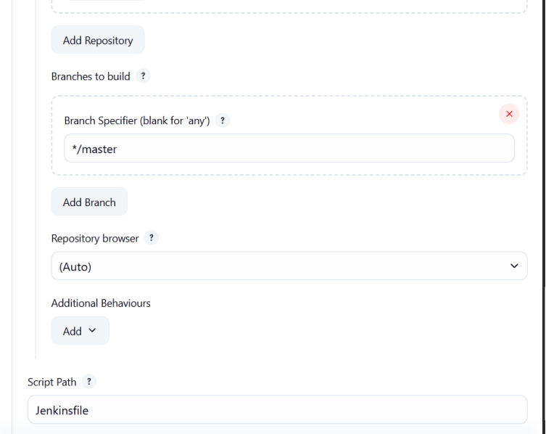

b)Run pipeline

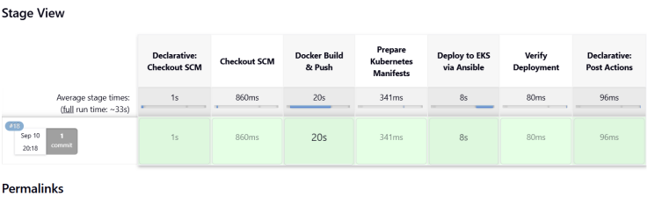

**Step 10. Confirmation**

a) Open Load Balancer and select your Load Balancer that has been created Copy the DNS link and open on Browser

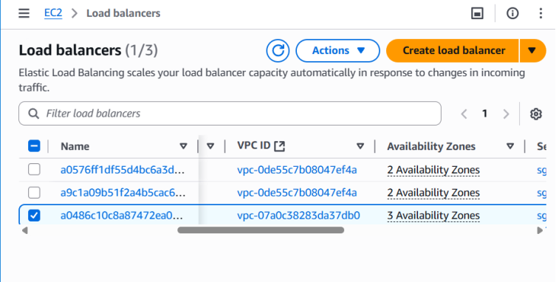

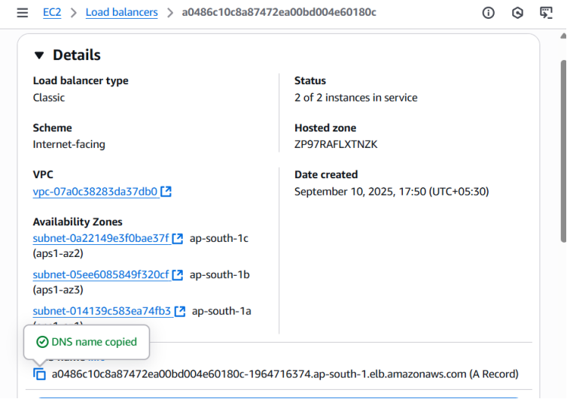

**The site is running**

